Please pray for us always!   | Philippine Missions  Jeremy and Kristine Ferguson – July/August 2009 Newsletter  www.jeremyferguson.org - jeremy@jeremyferguson.org  Highland Baptist Church  Gainesville, Florida (352) 373-2138 - www.highlandsmbc.org | 

Dear Family and Friends, August 31, 2009

God is truly incredible in His power! I was recently considering His promise in Matthew 16:18 and Romans 8:31 where He shows us how He will fight for us. There have been so many problems and obstacles along the path here over the past 5+ years that I often don’t even have the time to write and tell you about each of them specifically. However, one of our continual difficulties in the ministry here is that we often see people move away to other areas as they search for work. We’ve seen many visitors and a few members move away recently so we ask you to pray for steady work for the people here in this area.

Another continual problem is the parents of some of the young people who continue hindering them from their desire to come to Church and learn more of the truth. Please continue praying for the Moncada family as well as Beverly as things are still the same for them. By God’s grace Jeriz is still able to attend and will be baptized soon. Please pray also for two sisters, Joana and Miajoy Calma. These two young teenagers have been faithfully attending for over a year now and had decided to be baptized also. However, their mother, who has never been a problem before, suddenly became opposed to them coming to Church. I believe the problem in this situation is that the mother wants her kids to stay home on Sunday and do house chores all day instead of going to Church. I have found this to be a problem in many instances so please pray for this. I took Joana and Miajoy home recently after Church and the mother came storming out of the house and she was obviously angry. She walked straight up to Joana and struck her on the back of the head. Then Joana and Miajoy ran off into the sugar cane field in front their house and the mother couldn’t chase after them. I tried asking the mother what the problem was, but she was just yelling and screaming and didn’t want to talk. Up to now I haven’t been able to talk with these two so we’re just praying that this mother will come to the Lord. Please pray for a young man named Arcel whom I recently mentioned in an email update. He really wants to continue coming to Church, but is being hindered by all of his relatives. He is in a really tough situation so please pray for him to rely on the Lord’s strength and be faithful.

Despite so many problems though the victories continue coming and we’re praising God for it all! Even as I write this newsletter I am filled with the strength that God gives us as we pour out our lives unto Him. It’s nearly 10pm here now and I’m physically exhausted, but I just came from a Bible study with nearly 10 people and two of them who are regularly attending Church have decided to be baptized. Also, one man at this Bible study has decided to start attending. He has wanted to attend for a while now, but he works every day of the week as his boss does not give him any day off. However, he has decided to stand up in faith and give God the day which He has set apart for Himself. As we see these wonderful victories we are truly strengthened on the inside!

Church attendance is getting really close to 200 nowadays and we’re praying for 500, 1,000, etc! It’s always hard being patient, but we know that the Lord will continue blessing us as we strive to preach the Gospel! We praise God for having 13 more people baptized these past two months! Make sure to look on our website to see some video coverage. We have 10 more baptisms set for early October so we are really thrilled about this. I have been challenging the people to be more active in witnessing and I showed them how the early Church was so active that they saw baptisms every day. They asked if that is truly possible and I said that it sure is, if only we will share the Gospel every day to those who are around us, evangelism is the key and the goal of the Church!

Please pray for our evangelical outreach in the public schools here. Teaching in the High School has become our #1 method for winning youth to Christ. We continue to see youth coming to Christ because of this ministry. We also continue to see children from the Elementary School coming to Church regularly so we really thank God for these doors that He has opened in these schools. Currently, we are praying for more opportunities to teach in the Public schools so please pray that God will work. Also, regarding education, I recently came to know that some of our young people would not be able to study in school this year because of financial problems in their families. I prayed about this and God put it on my heart to help them out so that they could continue studying in school this year. Please pray for us as we help out financially in this area as our budget is very limited, yet we believe that God will provide.

An exciting piece of evangelical news comes from a discussion I recently had with a minister from a cults and several of the members. There is a cult in the Philippines known as “Iglesia ni Cristo” which holds to many heresies, including denying the deity of Jesus Christ. God gave me the opportunity of sharing the truth to one of their congregations recently as I was challenged to a debate by one of their ministers. In the debate I proved to them the deity of Christ as written in the KJV. Their minister claimed that the KJV has errors in its translations which I clearly disproved. One of the focus versus was Hebrews 1:8 which they really dislike. The minister also said that 1 John 5:7 is not found in the original Greek, but he was quickly silenced when I displayed a copy of a Greek manuscript which proves that 1 John 5:7 in the KJV is the proper translation. This minister admitted to me afterwards that he has more research to do so please pray that he will come to the truth and be converted as well as the people who listened to this discussion. There were over 100 people from this cult who came to listen and I could see shock and wonder on some of their faces as they listened to the truth. Some of them asked some good questions like, “If Jesus is God wouldn’t that mean that there are 2 Gods?” When I gave them the answers from the Bible they were left speechless and I challenged them to accept what the Bible says and reject what men say. One man was trying to trip me up and he asked, “If you say there is only one Holy Spirit then who are the seven Holy Spirits mentioned in Revelation 5:6?” I read the verse to him and showed him clearly that there are not seven Holy Spirits mentioned in this verse, rather seven Spirits. I showed him that he was guilty of trying to add words to the Bible to confuse the truth and he was quickly put to silence. I think that some of the people were enlightened when they saw that their fellow member was trying to do this. I will be attempting to setup further discussion with these lost people so please pray that the Lord will work it out. I posted a short video clip from this event on the website so you might want to check it out.

Please continue praying as well for our Bible school and the students currently studying. One young man, Jean, has surrendered to do ministry work, praise God! I won this young man to the Lord last year at a High School Bible study and he has been on fire ever since. Please pray for God’s will to be accomplished in his life. He is already bringing many other people into the Church. Some of our Bible students started an outreach in a barrio about 30 minutes away from our location here and it has immediately become fruitful as we have four people there who are now baptized and nearly 20 who are attending Church. Please pray that each of these Bible students will be used by the Lord in mighty ways! In these regards, please continue praying for our mission’s works, both local and foreign. We have a guest missionary coming to speak all day on September 6th. This man is a Filipino and he and his family are missionaries to Indonesia. Please pray that the involvement of the Church here in foreign missions will also increase.

Please pray also for the health of one of our older members, Sis Lelaine, whom I also mentioned in a recent email update. She suffered her 4th stroke recently, but is back home now recovering. She is unable to walk and is asking for the Lord to give her strength to walk again so she can come back to Church. Please pray for this as well as her relatives whom we have witnessed to recently also.

Lastly, our family is doing great. Josh turned four years old this September 1st and he is growing up quickly, physically, mentally, and spiritually. Physically he is taller than many other children here who are 6 or 7 years old! I just measured him and he is 42 inches tall. Mentally he is incredibly smart and he’s at that age where he just absorbs everything new he sees and learns. Spiritually he is becoming very interested in God as he loves to look at his baby Bible and talk about the Cross and other Bible stories. When you ask him why there is Hell he says it’s for the “bad boys and bad girls”. Then if you ask him who is a bad boy he will answer, “Josh and all people”. It’s incredible how easy it is for children to learn such simple truths. I recently shared the Bible with a middle-aged man and it took me 30 minutes just to get him to understand that he is a sinner and when he realized that he was going to Hell as a sinner he said, “Bahala”, which basically means, “Oh well”. Then I asked him if he wanted to learn how to be saved so he could avoid Hell and get to Heaven he said, “Huwag na” which means, “No thanks”. I thank God that Josh if far more interested in the truth than that man was! We have posted some new family videos on the website so feel free to check them out and catch a small glimpse of our life here. Thanks for all that you do for the ministry here, please continue holding the rope for us through your faithful prayer and financial support. God bless you all!
Yours in Christ,
Ferguson Family
1 Corinthians 16:9, “Sapagka't sa akin ay nabuksan ang isang pintuang malaki at mapapakinabangan, at marami ang mga kaaway…For a great door and effectual is opened unto me, and there are many adversaries.”

Pictures From Recent Baptist

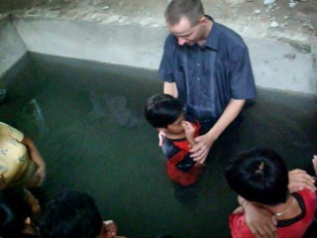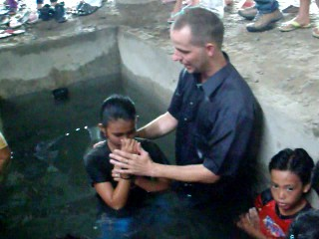

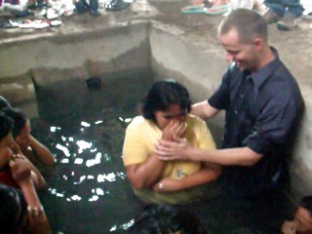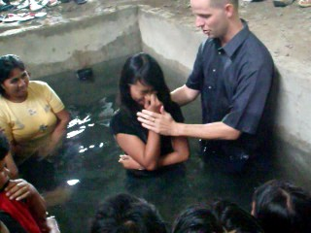

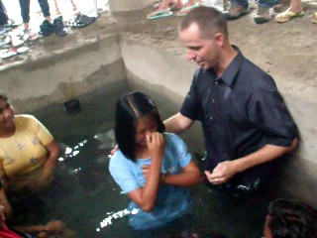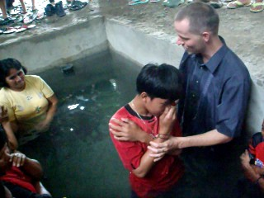
Pictures From Recent Baptist

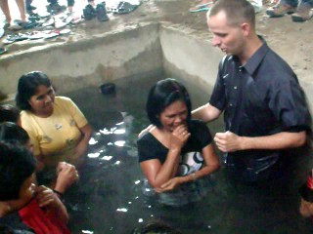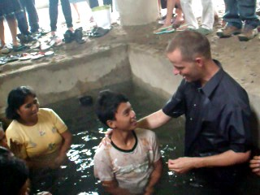

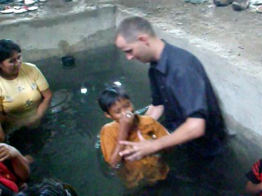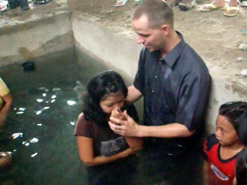

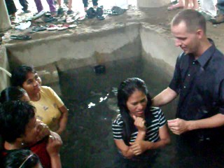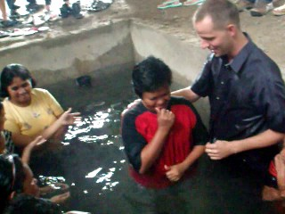

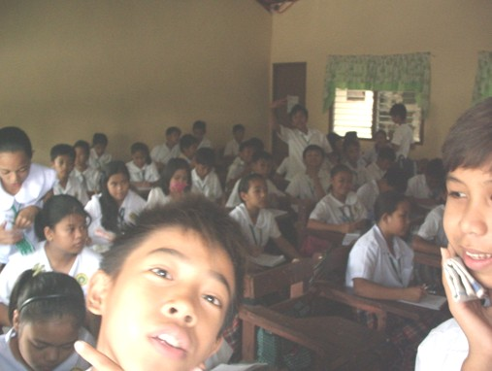
Students listening to Bible Study at Elementary School

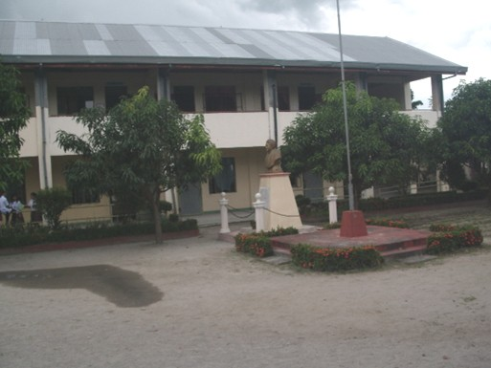
This is the High School where we conduct weekly Bible Studies
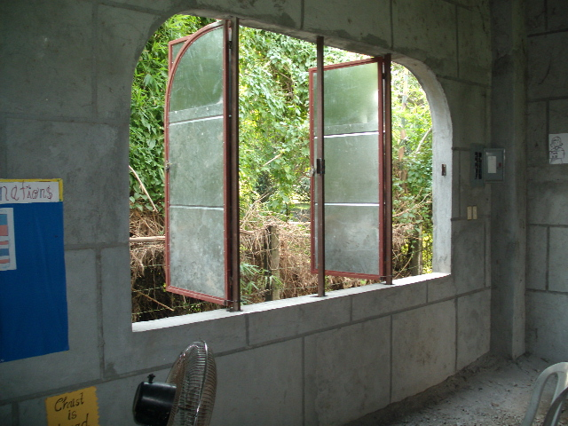
We have nearly finished assembling and installing the windows in the Church building

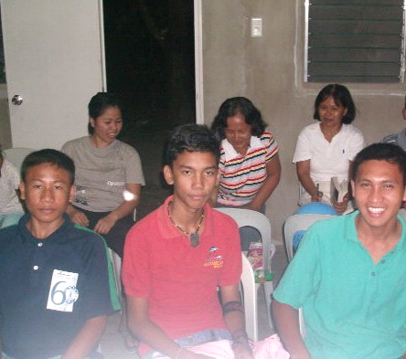
Some of the students in the Bible Institute

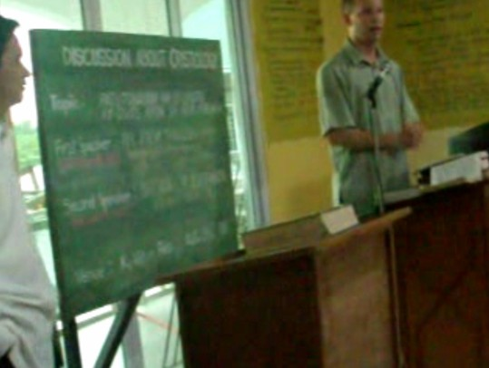
Jeremy teaching the Deity of Christ at Debate

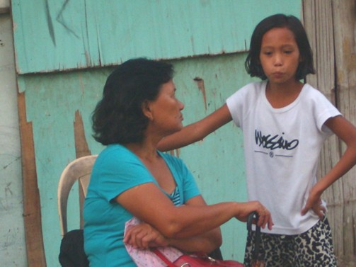
This is Joana (whom I mentioned above) talking to Sis. Meding

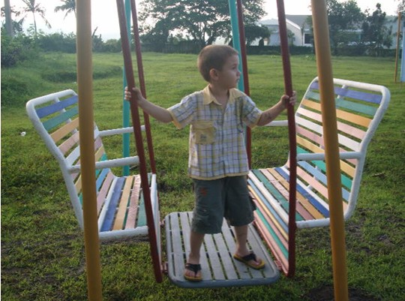
Recent picture of Josh


Recent picture of Josh

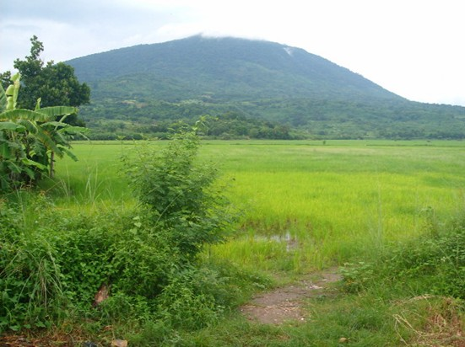
Picture from rice field

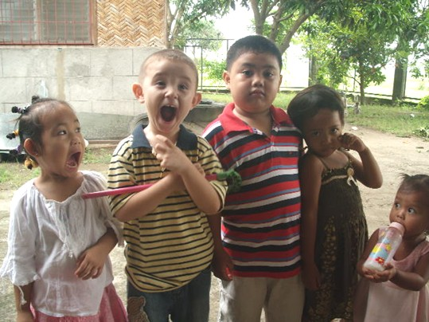
Children at Church


Josh acting goofy!

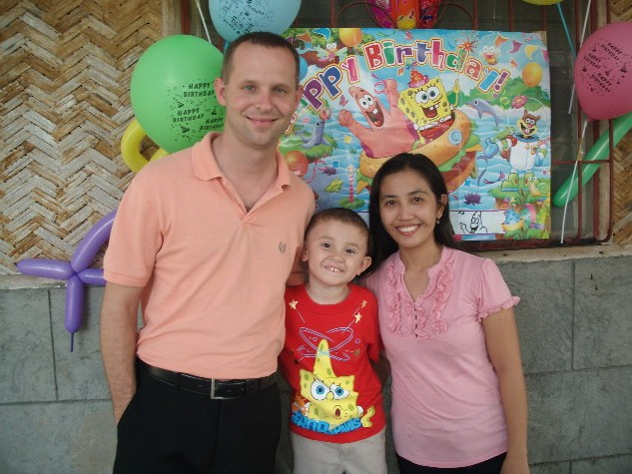
Josh turns four years old

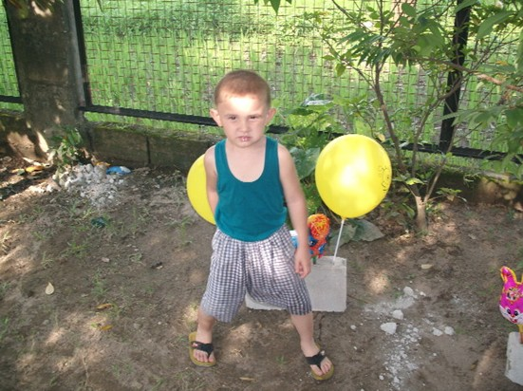
Josh on his 4th Birthday

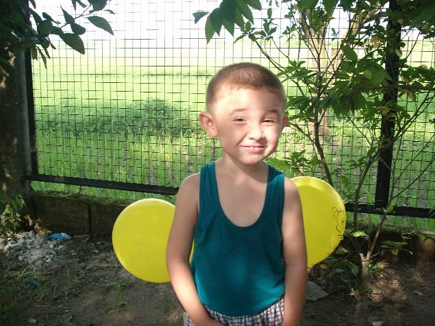
Josh on his 4th Birthday
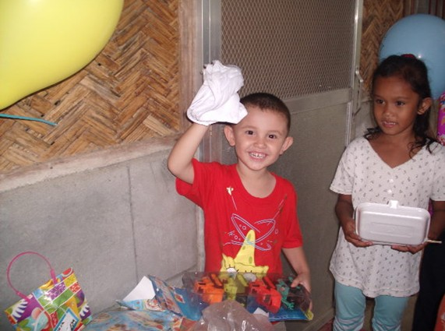
Josh on his 4th Birthday

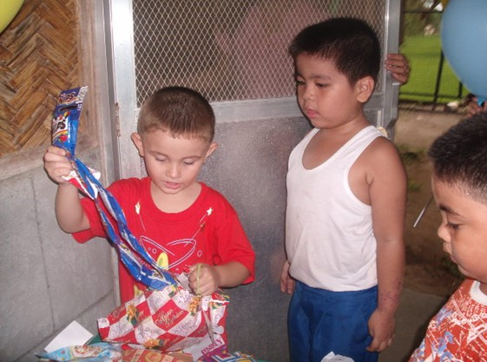
Josh on his 4th Birthday

