Philippine Missions



January-February 2017 Prayer Requests and Newsletter

The Ferguson Family – www.jeremyferguson.org

Highland Missionary Baptist Church
Gainesville, Florida (352) 373-2138 - www.highlandsmbc.org


Dear Praying Mission Partners, March 2, 2017

Patience, patience, and more patience. When God wants to teach you patience He might puncture your motorcycle's rear tire out in the middle of nowhere, without a vulcanizing shop anywhere nearby. That’s one of the little experiences God has recently used to increase my faith here the mission field. While we’ve patiently served the Lord here over the past 13 years we’ve seen the Lord add on more and more and are excited to see things shifting from addition mode to multiplication mode! We started everything here from literally nothing back in 2003 and it blesses our hearts so much to see what God has already accomplished! We are simply instruments for His glory; please pray that He would use us more and more!

Our first church plant at New Life Baptist Church, Mexico, Pampanga recently celebrated her 13th anniversary and God blessed the entire day with over 300 in attendance in the morning service and nearly as many in the afternoon service also! There were new and returning visitors, some folks from our Aeta ministry, preaching from Bro Daryl and myself, several professions of faith, nine baptisms, special singing, tearful testimonies, a ministry video presentation, great food and fellowship, and so much more! Please pray for this church to keep on going forward and win more and more people to Christ!

God mightly blessed the missions emphasis month at this church last February. Through the preaching of different missionaries, mission-minded pastors, and myself the congregation was reminded and challenged to do more for the cause of missions! They reneewed their faith promise for missions and are now currently promising to give nearly 38,000 pesos per month towards their mission program! This will allow that church to send out more missionaries and, at the same time, expand her current program to support more mission works, both local and foreign! Please pray for the members to fulfill their promise. In the past several years they have been very faithul in fulfilling their faith promise for missions and we believe they will continue to do so.

That church is also currently expanding and improving her Sunday school classrooms. It’s a blessing to see some of the members putting in extra volunteer time after their jobs to work on this! They aren't paid a single peso for their labor and they even provided some of the materials for free! Praise God as there are so many members at this church who put a lot of effort into their ministries!
.
Please continue praying hard for our Aeta mission work. The two Aeta churches are doing very well with strong attendance, regualr visitors, and more baptisms recently! Missionary Daryl Lalu is doing a fantastic job in leading this work. The first Aeta church plant has already saved up 30,000 pesos for their own building project and are looking for the right location. Please pray for them in this endevaour, that the Lord would provide the right piece of land so that they can get their building project going soon. Their current church hut is overflowing with 70 in regular attendance. We’re seeing good growth also in their desire to be mission partners. They’ve recently increased their monthly giving to missions and are giving towards their Aeta mission point as well as supporting two foreign Filipino missionaries (one in Bangladesh and another in Zambia)! Please pray also for our second Aeta church plant as they are currently going through a stewardship month.

Please continue praying for the Philippine Baptist Disaster Relief Ministry. This is really turning into an awesome opportunity to reach a lot of people throughout the Philippines with the gospel! After the recent typhoon Nina relief efforts we were able to minister to people in Surigao City who were affected by a powerful, 6.7 magnitude earthquake that hit on February 10. Working with some local pastors we were able to preach the gospel and distribute relief items to over 300 people and there were over 100 professions of faith, praise God! The Lord also blessed the PBDRM ministry with two more supporting Filipino churches! Please pray for more souls to be saved through this ministry and for more Filipino churches to support PBDRM.

Other prayer requests:
- Bro Mike from our church in Mexico, Pampanga. He has resigned fom his managerial position at a resaraunt and, along with his wife, they are now doing full time evangelistic work.
- Grandma Lelaine from our church in Mexico, Pampanga. Her departure to Heaven appears to be very soon as her frail body is reaching her limits. Please pray for God's comfort to cover her at this time. Please pray also for the salvation of her lost family members. By God's grace we were able to share the gospel recently to several of them. Sis Lelaine’s prayer has always been for her family to be saved.
- The students at our two Bible Colleges. Please pray also for more church members to enrol.
- Upcoming VBS ministries in April. Our church in Mexico, Pampanga is praying to have over 1,000 students in their five day VBS and we will be conducting VBS’s among the Aeta also. Please pray for ministry friends Sis Sandra Hancock and Sis Elizabeth Hancock from Gainesville, Florida who will be coming to assist with this effort.
- Our upcoming orphanage / home for the helpless. Our main need is for monthly sponsors and funds to purchase land and start construction. Praise God for Ancient Landmark Baptist Church in Plaridel, Bulacan who has started to support this ministry!

In closing, I would like to share a little story of faith. A youth at our church in Mexico, Pampanga wanted to join the mini-orchestra ministry so she spent a couple of months saving up 2,500 pesos to order her a violin. We don't give our people free handouts here, we teach them to work for what they have. We didn't purchase a single instrument for the brethren in that mini orchestra; they all bought their own instruments with their own money. How is it that these “poor” Filipinos are able to support their own pastors, send out and fully support their own missionaries, purchase their own land, and build their own buildings WITHOUT financial assistance from American churches??? By FAITH and SACRIFICE! Let us walk by faith, not by sight!

Yours in Christ, Ferguson Family

Luke 19:13, " Occupy till I come"

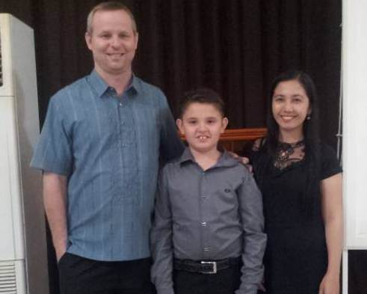
Recent services and baptisms at New Life Baptist Church, Mexico, Pampanga

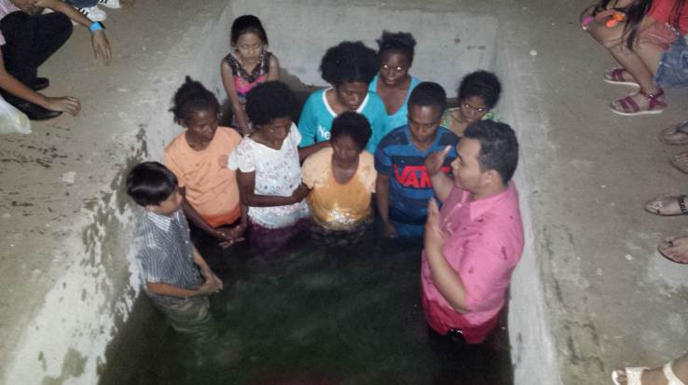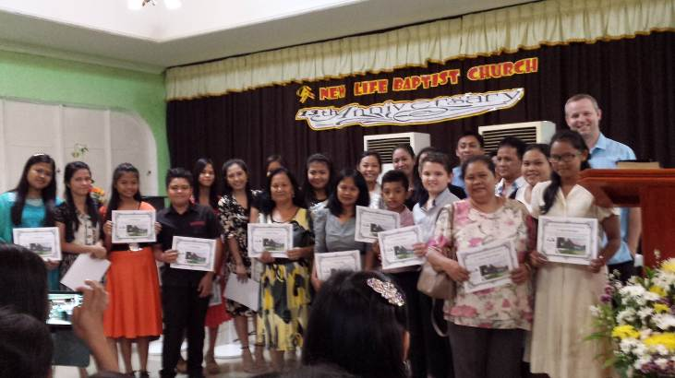

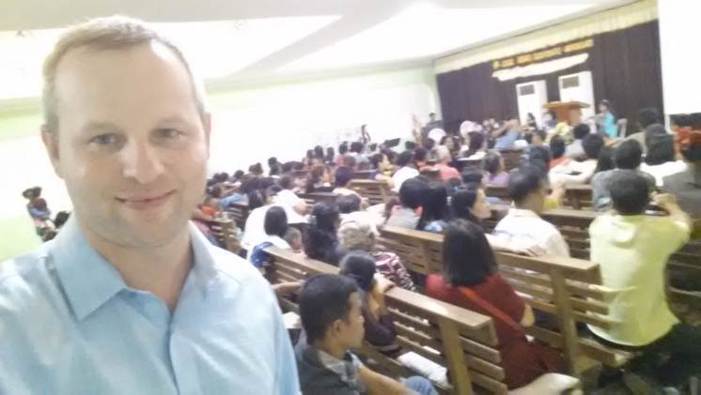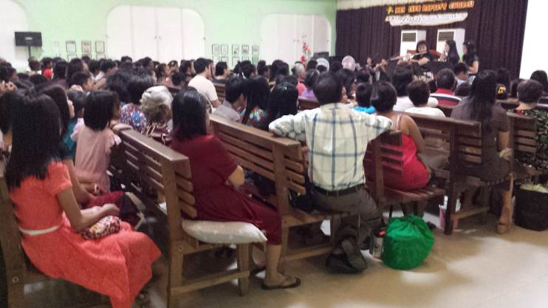

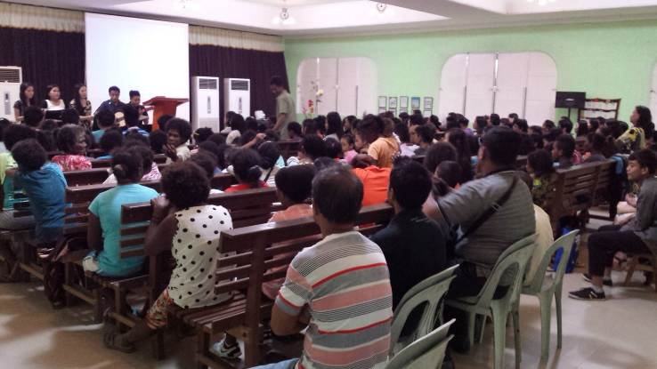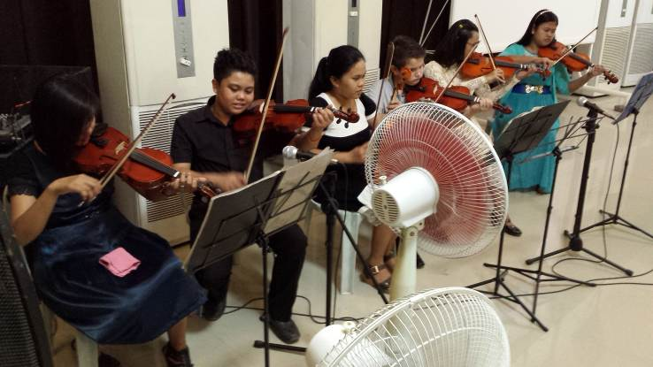

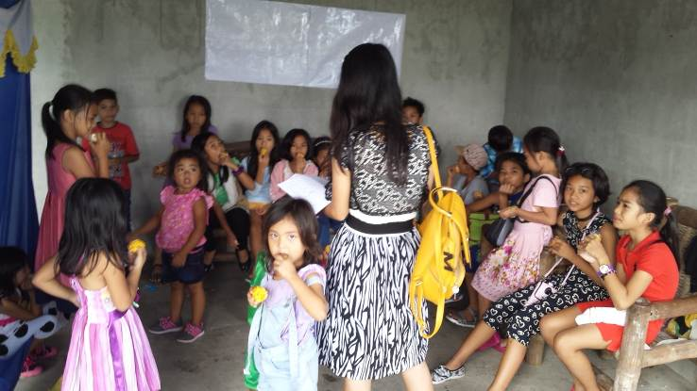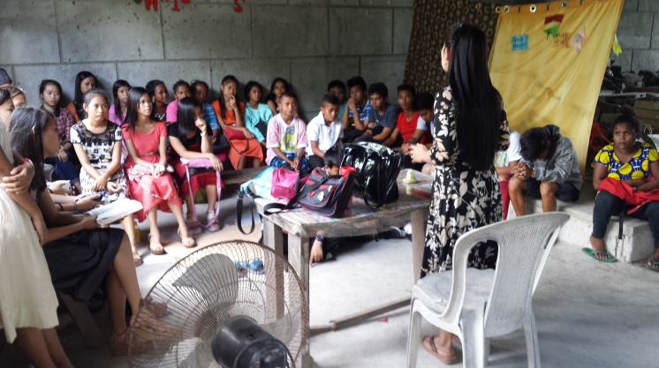
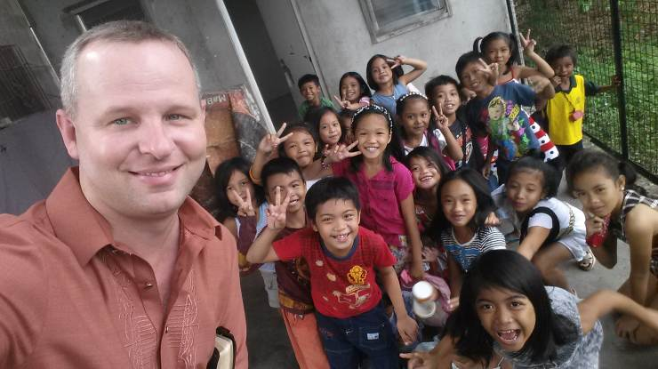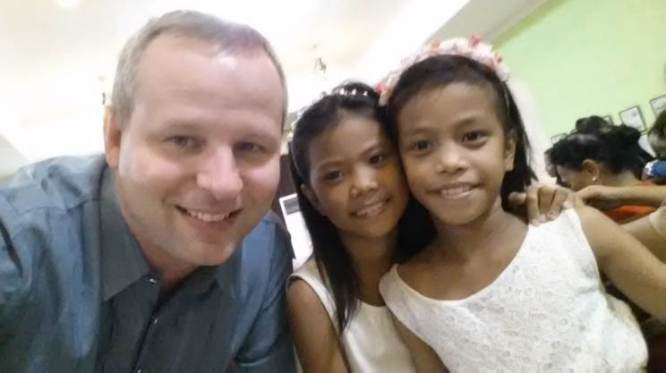

Some of the guest preachers at our recent mission emphasis month

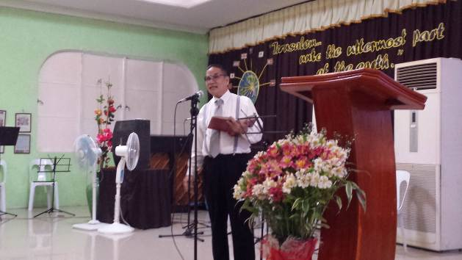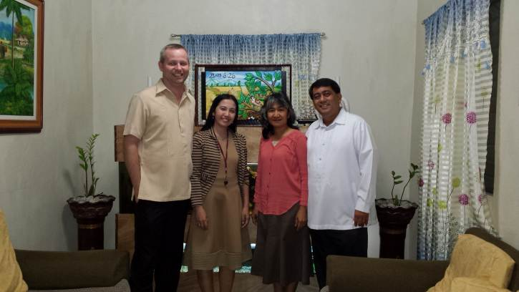

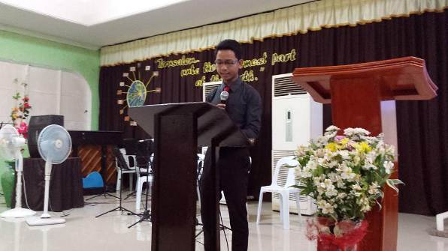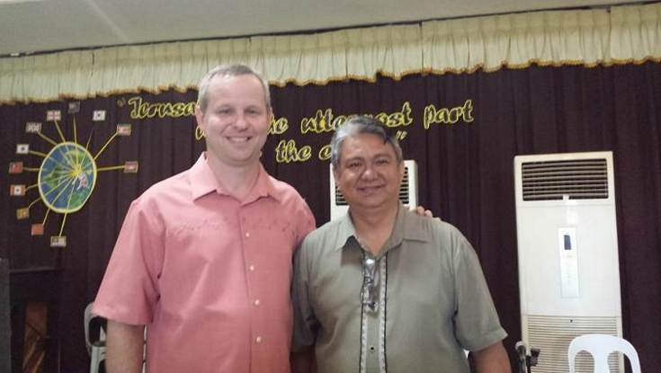

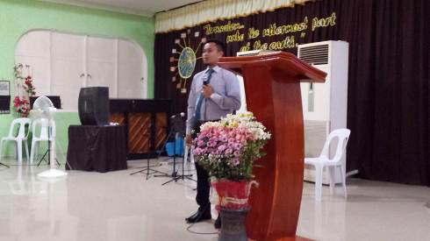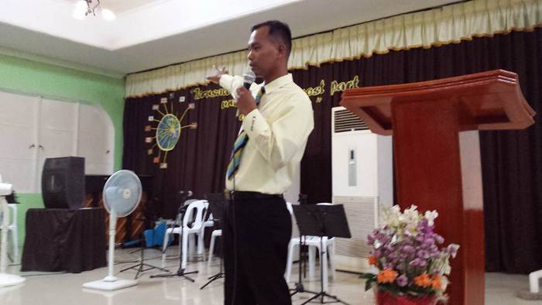
Witnessing to young people out in the streets is a great open door here

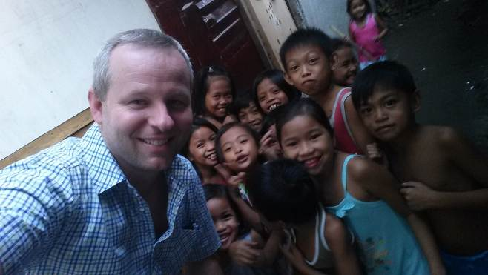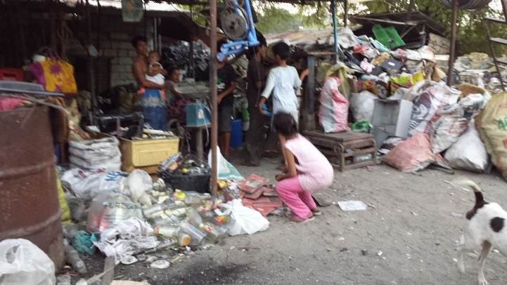

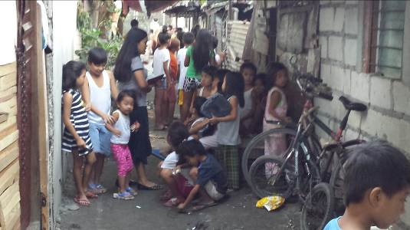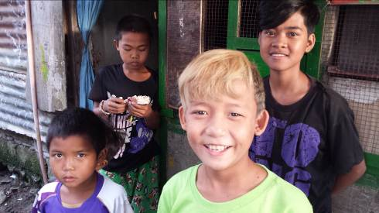

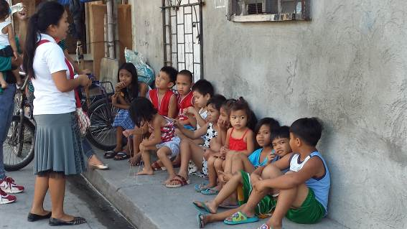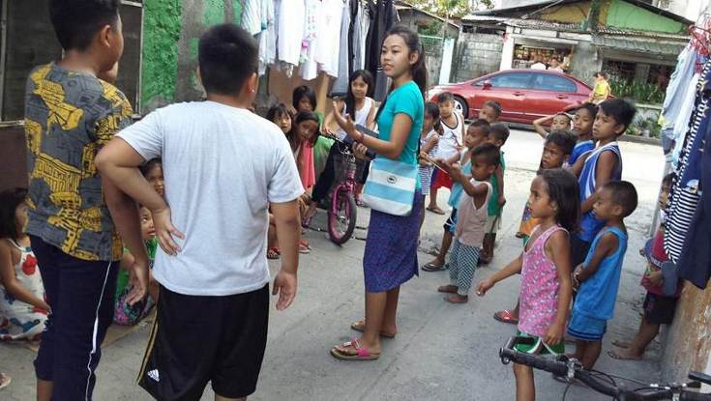

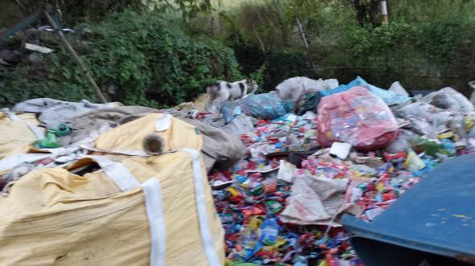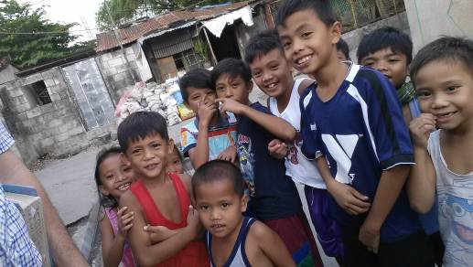

Bible College Program at New Life Baptist Church, Mexico, Pampanga

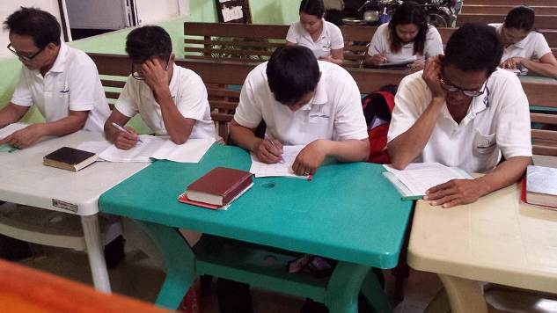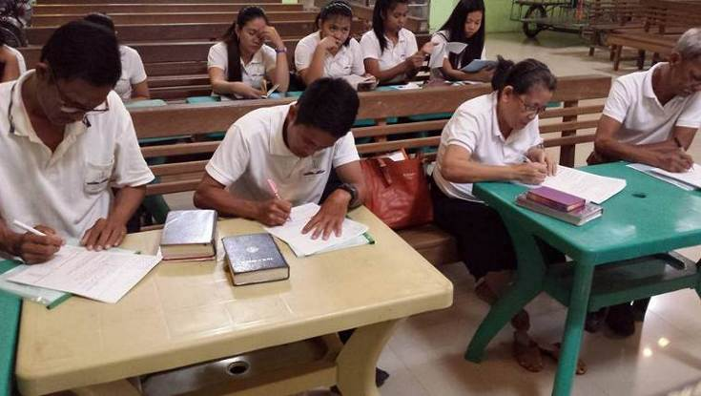

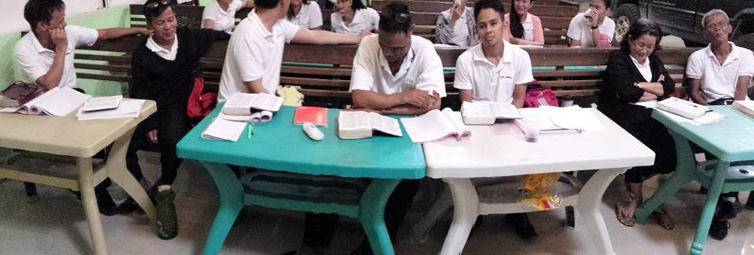

Public school ministry – reaching 2,000+ students WEEKLY with the gospel!

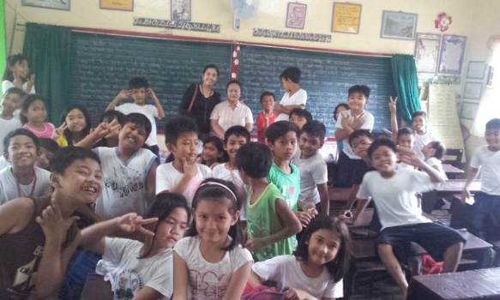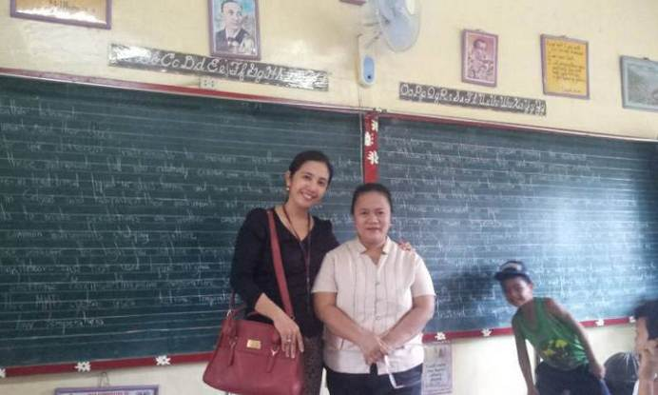

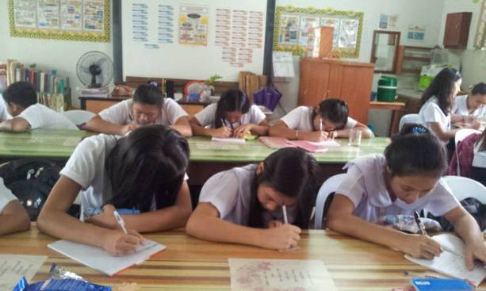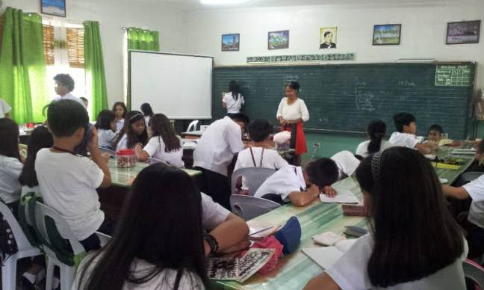

We recently investigated a new, potential mission point today at a mountain area. One guy I witnessed to out in the middle of nowhere had six kids and the entire family was willing to listen to the gospel. Pray for more genuine missionaries to be raised up! The harvest truly is plenteous, but the labourers are few

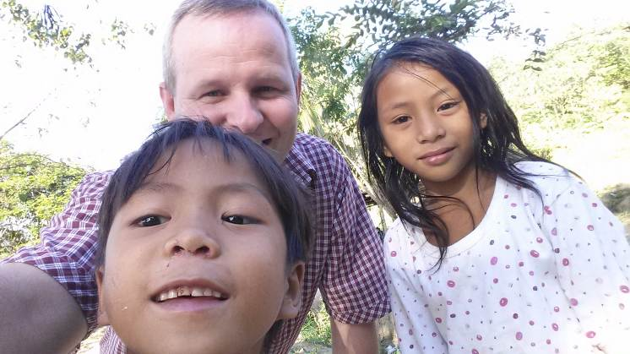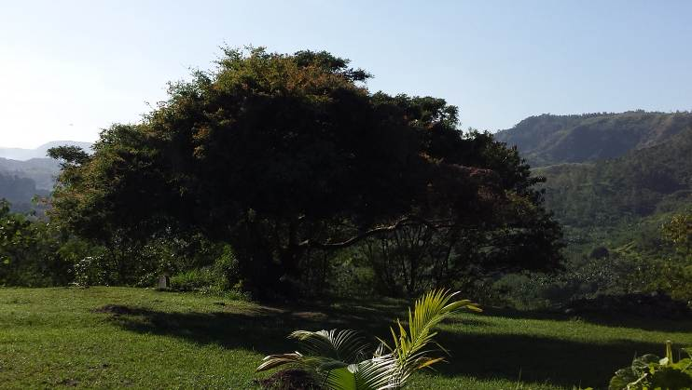

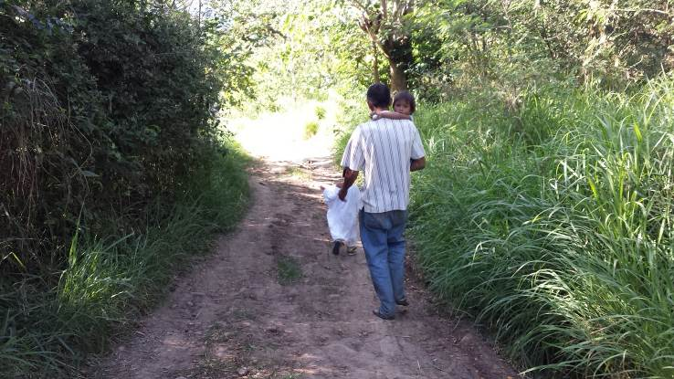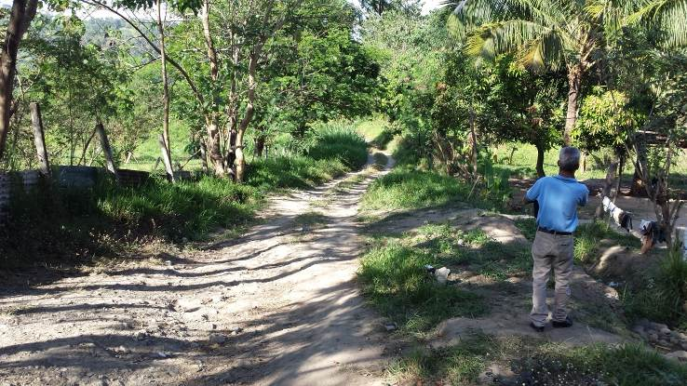

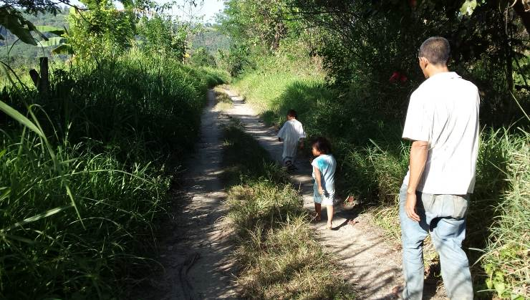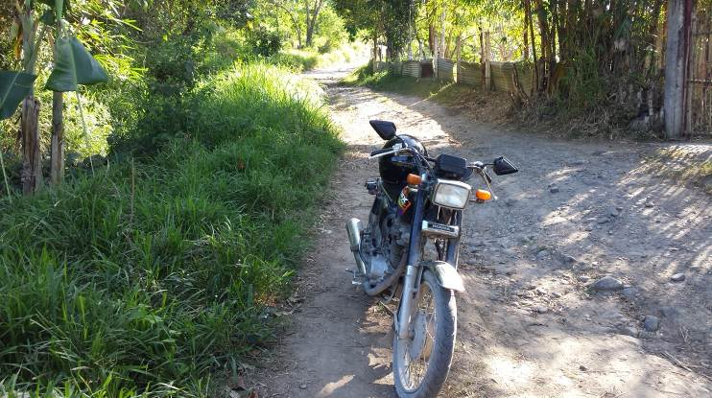

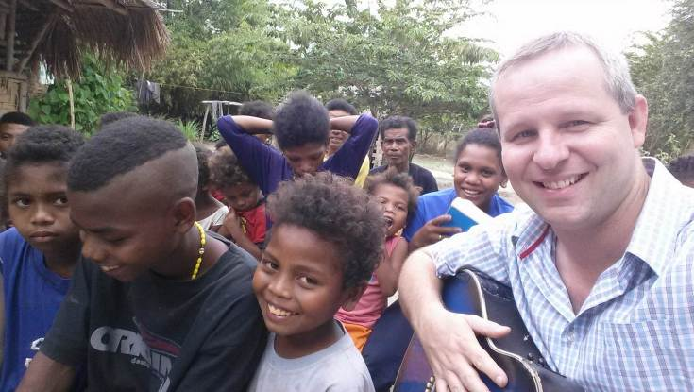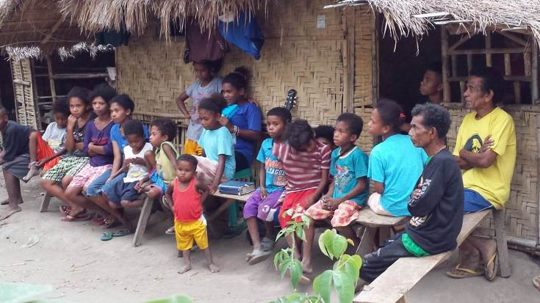
Recent ministry work among the Aeta

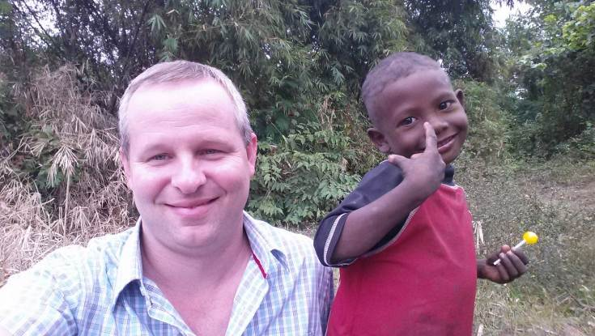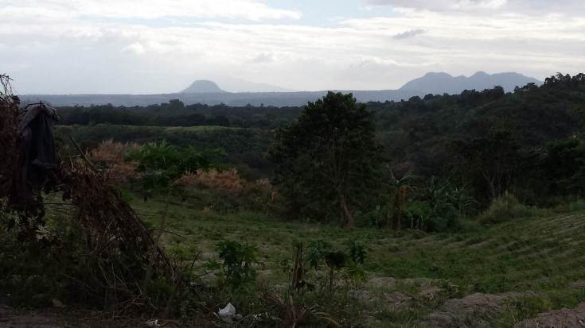

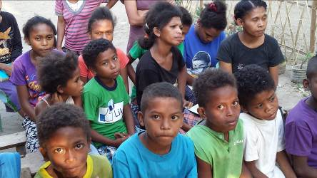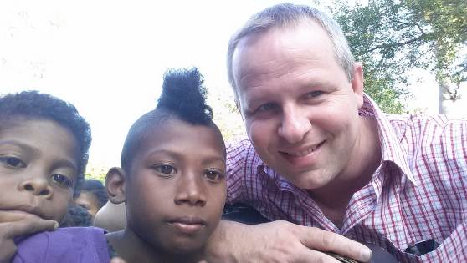

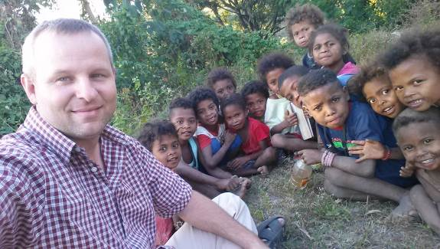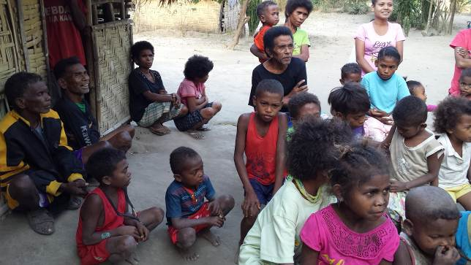

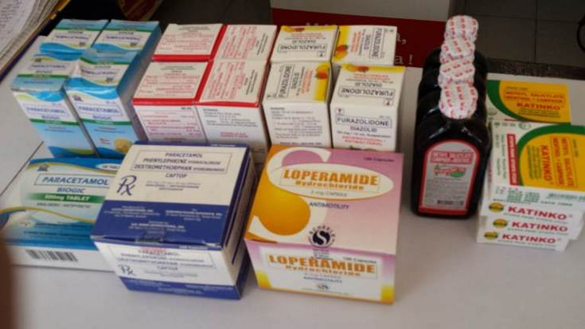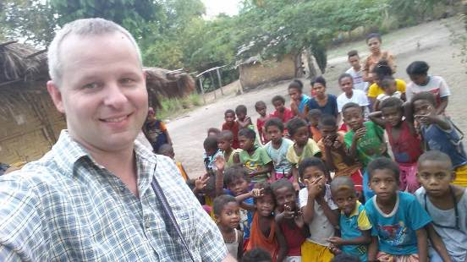
Recent PBDRM ministry work in Surigao City

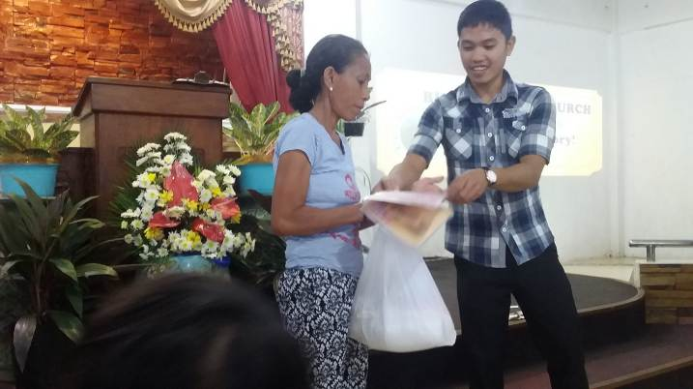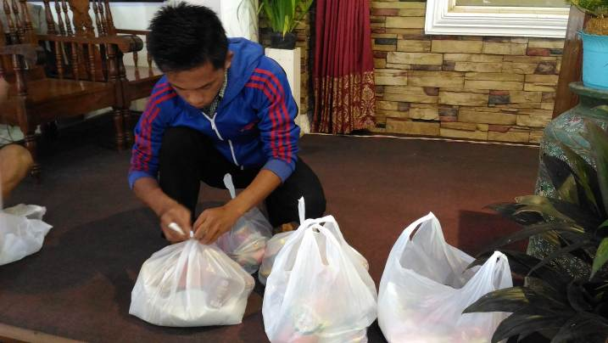

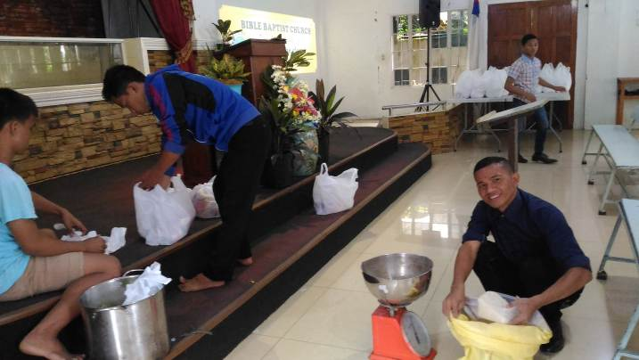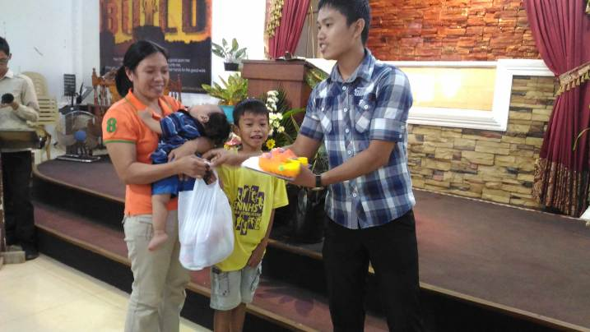

Aftermath of the earthquake

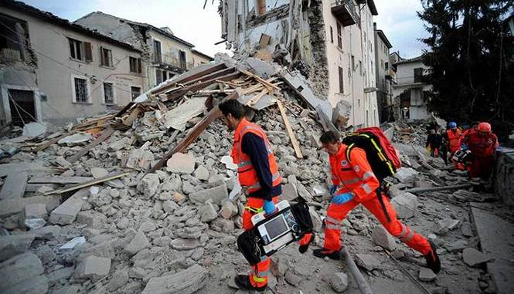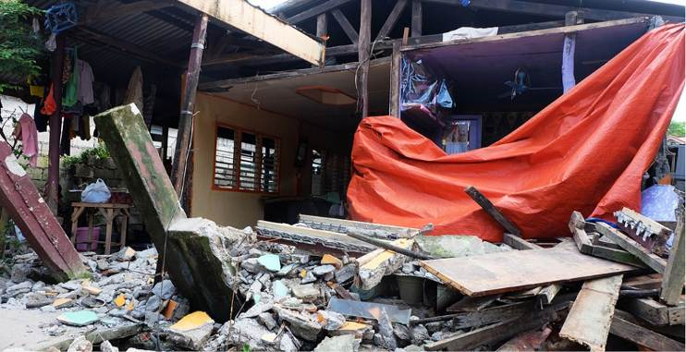

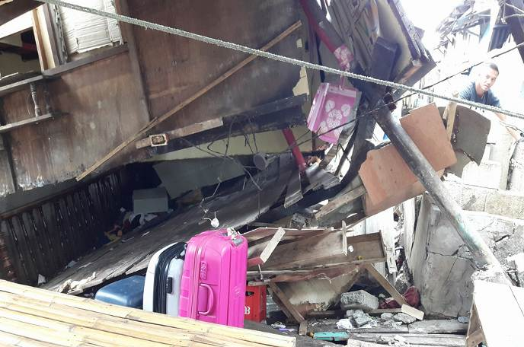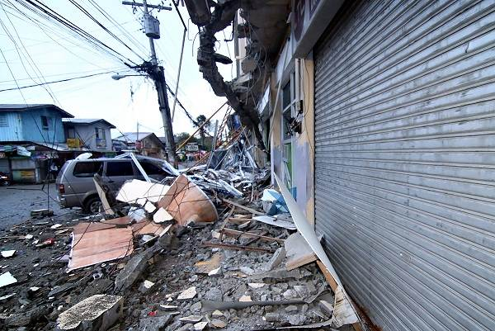
Recent mission conference at Ancient Landmark Baptist Church in Plaridel, Bulacan

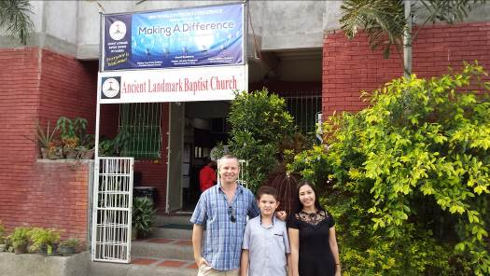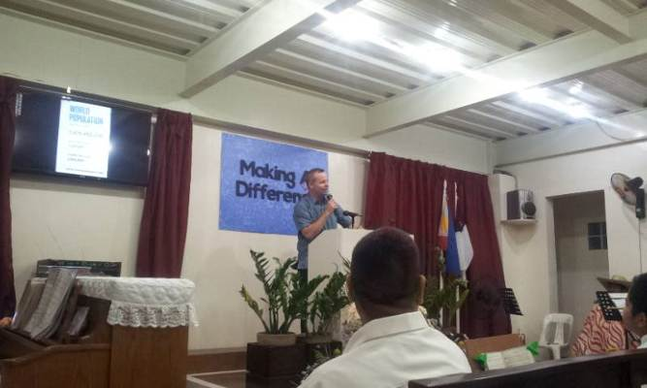

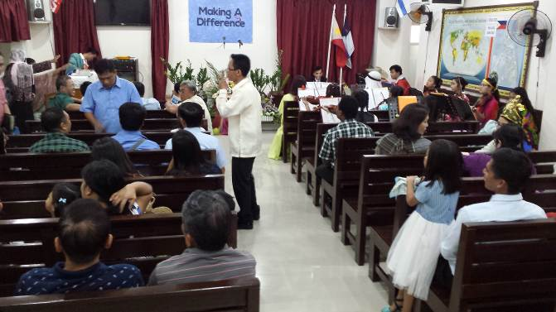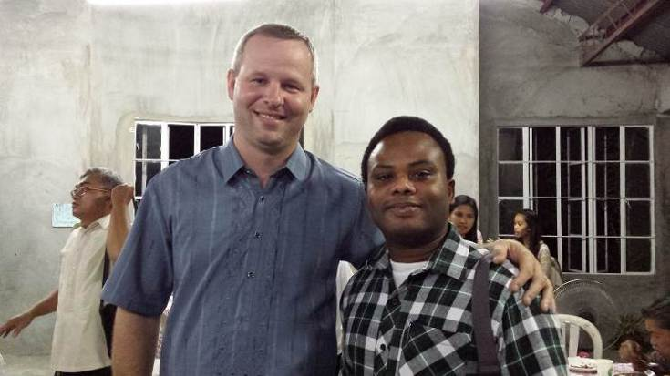

Recent soul winning conference at Fortress Baptist Church in St. Rose, Laguna

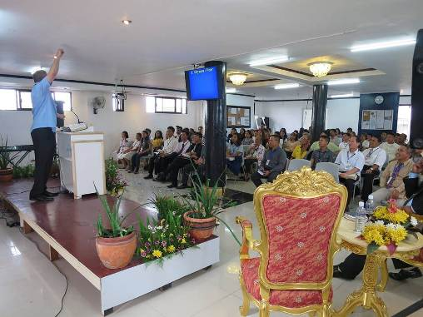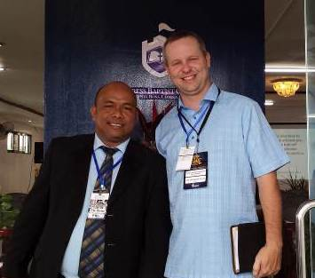

Check out our webpage for more information: (www.jeremyferguson.org)

*You can also see MANY more pictures and more FREQUENT UPDATES on Jeremy’s Facebook *

