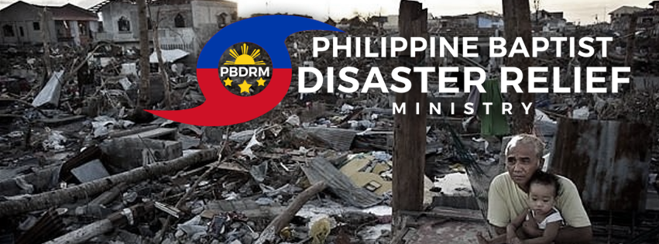
June 2017 Prayer Requests and Newsletter
Sponsoring Church: New Life Baptist Church, Mexico, Pampanga
Director: Missionary Pastor Jeremy Ferguson

Dear Ministry Partner, June 28, 2017

The months of March through May were pretty quiet, almost like the calm before a storm now that I look back on everything. At the end of May we discovered a new type of disaster in which we could minister: the man-made disaster of battles and war. When the ISIS inspired Maute group took over Marawi City in Mindanao many civilians were killed and there were over 300,000 evacuees (majority Muslim) who fled into nearby areas where they have friends and family while others poured into evacuation centers. While the situation remains chaotic it did open us an incredible door of opportunity to show the love of Christ and share the gospel to a large group of Muslims that can be very difficult to witness to.

PBDRM coordinated with Metro Iligan Baptist Church (Pastor Pol Fontillas) in Iligan City and by God’s grace we were able to reach over 500 families through these recent distributions. We’re very thankful to Pastor Pol and the many members of his church who were so eager to assist! Each of the families received a small food pack with rice and canned goods and also a gospel tract written in the Cebuano language. Please pray for the seed that has been planted and hearts to be opened and see their need for Jesus Christ, the only hope for all mankind! Hearts tend to be more open to the gospel during these times of disaster and our number 1 goal is to share the gospel to these affected people as we remember that people often won’t care about what we believe until they believe that we care. This is especially true when it comes to Muslims. Anyone who is effective in witnessing to Muslims will tell you how important it is to first show them that you are indeed a true friend.

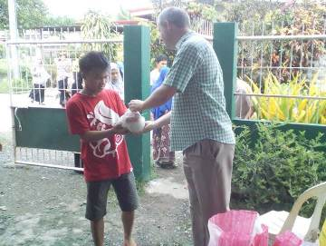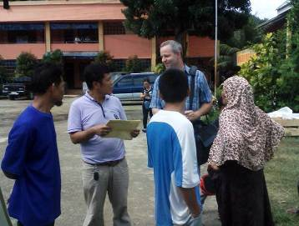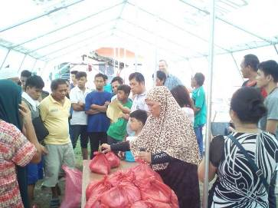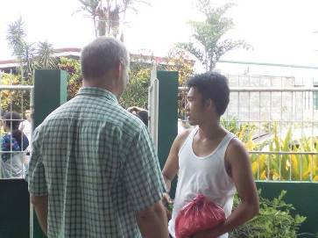

Many of these evacuees have no idea what they’re going to do with their lives; I really can’t imagine being in their situation, what all they must be feeling and thinking. Many of them told me that even when the time comes that they will be allowed back into Marawi there is nothing for them because they have already seen pictures of their destroyed homes. When the fighting first erupted in Marawi most of the people literally left everything behind, escaping for their lives. I spoke with one young man who had a Maute terrorist point a gun in his face when a lady intervened just in time and saved his life. One college student told me that their school in Marawi has already suspended classes for the entire year and her dreams of becoming a teacher are now on hold. This young lady listened to the gospel with an open heart and told me that she now realizes there is a big difference between Jesus and the god she worships. Praise God that some of these people are thinking about the truth!
We praise God because PBDRM has really become a very effective, unique tool for reaching the lost here in the Philippines! I wish each of you were with me during this recent time of disaster relief ministry because witnessing to the Muslim evacuees was an incredible experience. Most of these people would rarely give you any time to share your faith with them, but we saw so many people willing to listen after we handed them relief packs. Even though the relief packs were a bit small they were really thankful for even the smallest amount of help that came their way. One of the places we visited was a Muslim Arabic school and even in that environment the people were very kind and receptive when they saw us bringing them the relief packs.

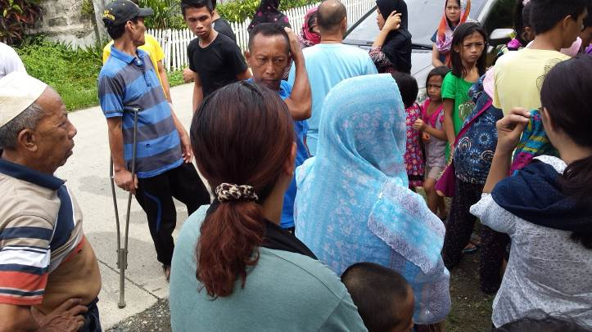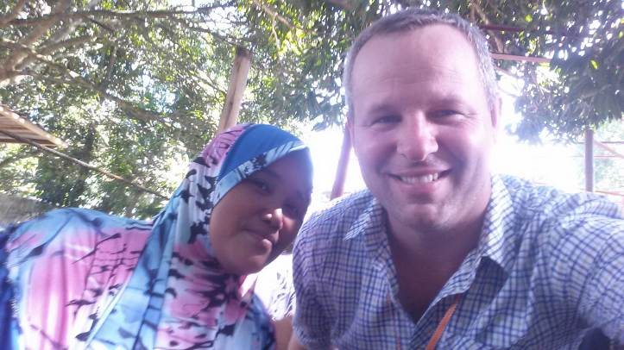

Please pray also for more churches and individual to support PBDRM on a monthly basis. Remember, 100% of donations to PBDRM go towards purchasing and distributing relief items to those who are most needy during times of disaster. All of the physical work conducted by PBDRM is on a volunteer basis, nobody receives any salary whatsoever. When conducting distributions among large groups of people the fund gets used up very quickly. The food packs we distributed to these 500 families were rather small and we would really like to have the ability to give them more in the future. A small food pack worth even P150 is barely enough to feed a family for one day. In the coming months there will still be a great need for food, medicine, and personal hygiene items for these evacuees. The evacuees are telling us that it will be at least two to three months before they will be allowed back into Marawi. Please pray that PBDRM will be able to quickly accumulate more funds so that we can put together another relief distribution among these evacuees in July.

PBDRM would like to thank three new supporting churches who recently gave an offering for the first time: Shield of Faith Bible Baptist Church in Makati, Manila (Ptr Ricky Mabazza), World in Need Baptist Church in Mandaue, Cebu (Ptr Kent Jesalva), Metro Iligan Baptist Church in Iligan City, Lanao del Norte (Ptr Pol Fontillas). Thanks also to every church and individual who is consistently supporting this ministry, without your financial support this ministry would not be possible.

Yours in Christ,
Pastor Jeremy Ferguson (Cellphone number: 09234798041)

PBDRM Facebook Page: www.facebook.com/PhilippineBaptistDisasterReliefMinistry

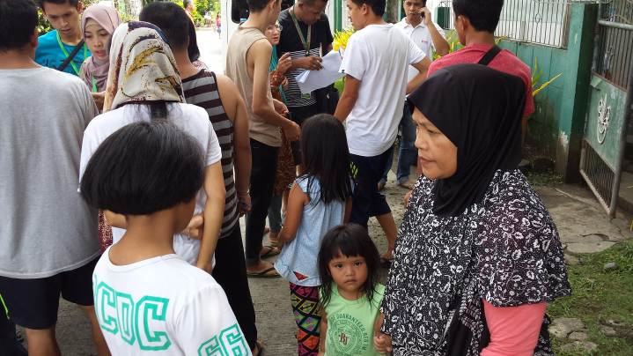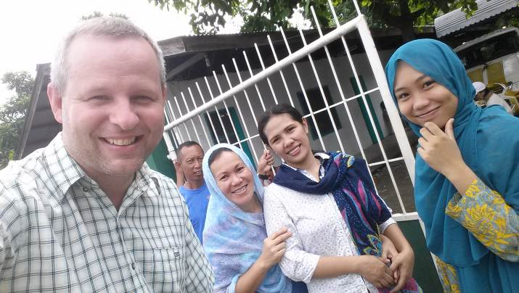

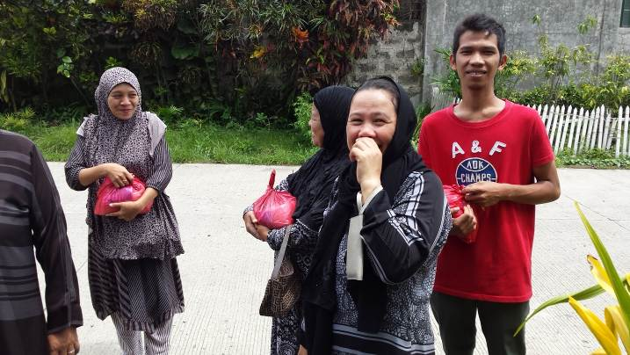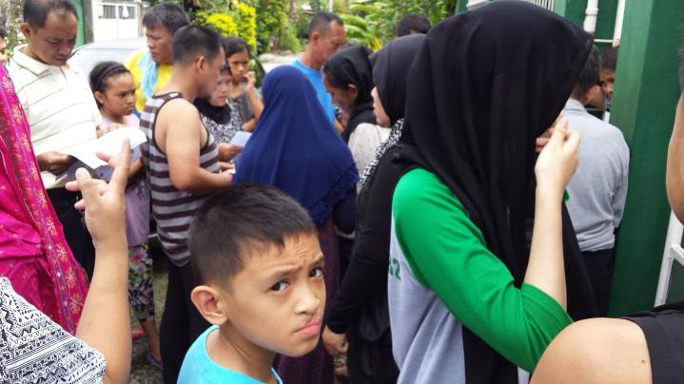

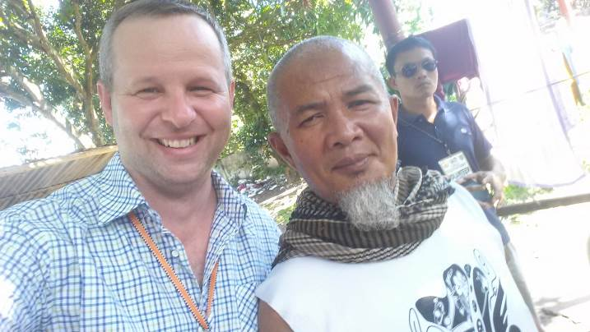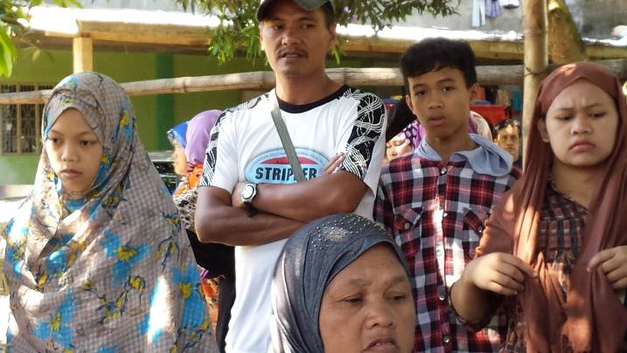

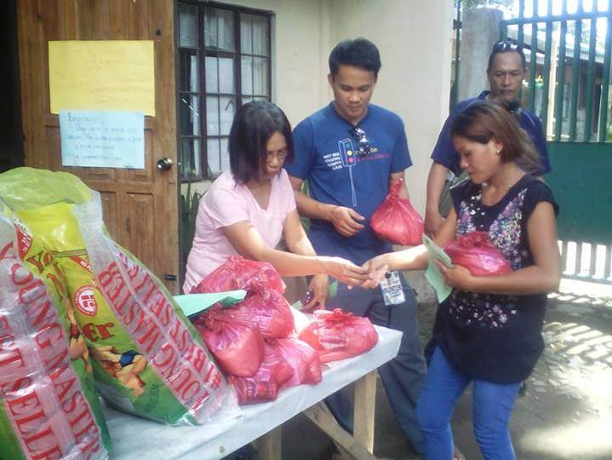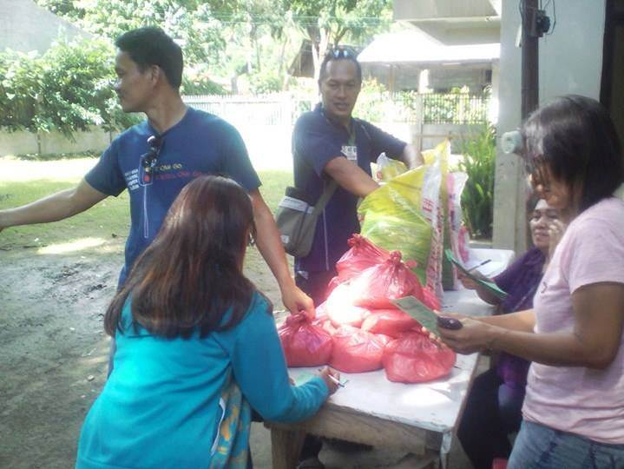
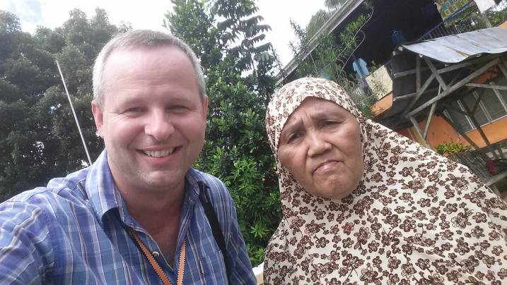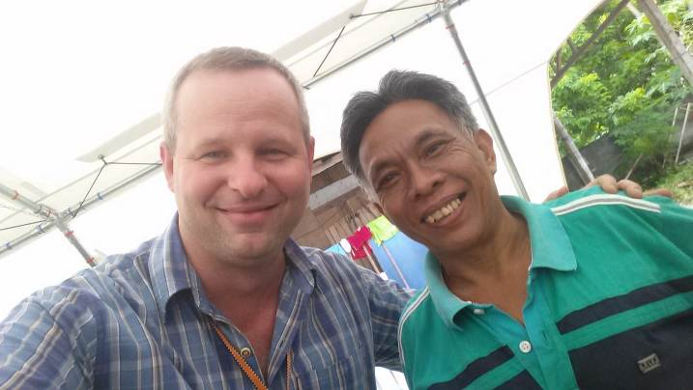

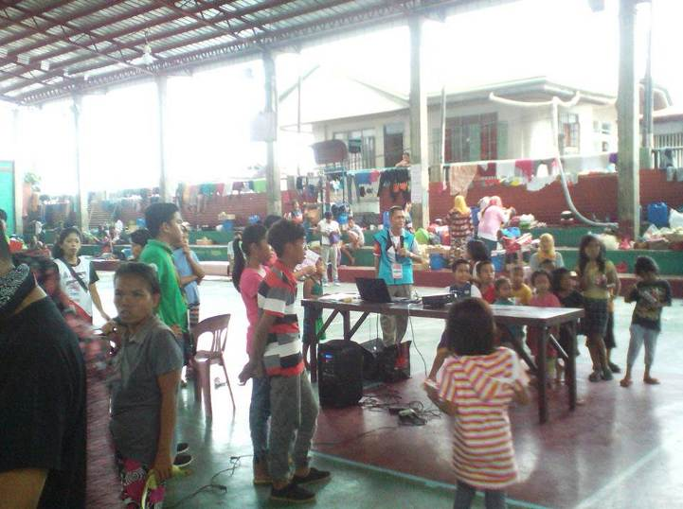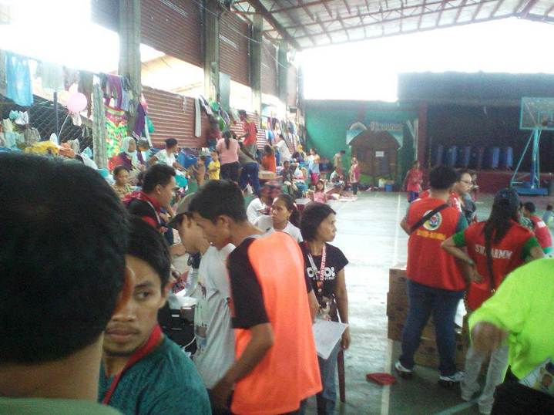

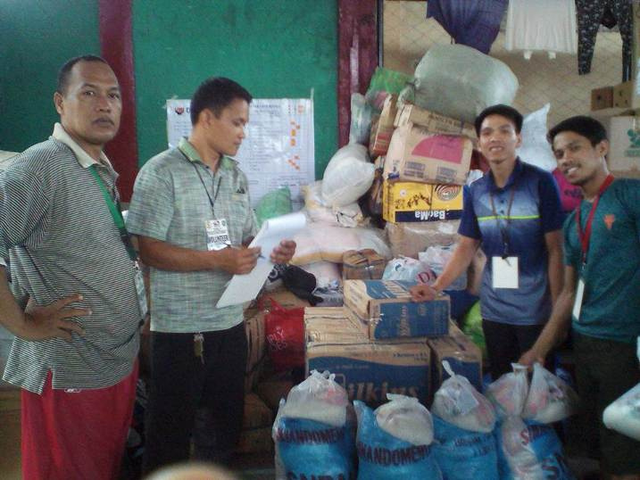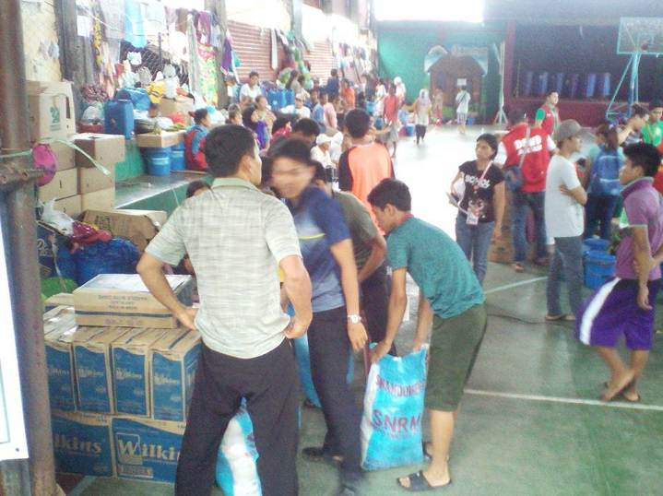
March 2017 Financial Report (in pesos)

Previous Balance (86,948) + Offerings (22,500) - Expenses (0) = Ending Balance (109,448)

Offerings
3/1/17: Angeles Missionary Baptist Church (Angeles City, Pampanga) = 1,500
3/12/17: Metrolight Gospel Baptist Church (Bustos, Bulacan) = 4,000
3/23/17: Ancient Landmark Baptist Church (Plaridel, Bulacan) = 2,000
3/23/17: Laloma Baptist Church (Laloma, Quezon) = 2,000
3/23/17: Hebron Baptist Church (Cainta, Rizal) = 500
3/23/17: Berean Baptist Church (Qatar) = 1,000
3/23/17: Individual Offering = 500
3/26/17: New Life Baptist Church (Mexico, Pampanga) = 1,000
3/26/17: Shield of Faith Bible Baptist Church (Makati, Manila) = 10,000

April 2017 Financial Report (in pesos)

Previous Balance (109,448) + Offerings (16,500) - Expenses (0) = Ending Balance (125,948)

Offerings
4/2/17: Metrolight Believers Baptist Church (San Jose del Monte, Bulacan) = 7,000
4/3/17: Angeles Missionary Baptist Church (Angeles City, Pampanga) = 1,500
4/9/17: Individual Offering = 500
4/21/17: Ancient Landmark Baptist Church (Plaridel, Bulacan) = 2,000
4/21/17: Laloma Baptist Church (Laloma, Quezon) = 2,000
4/21/17: Hebron Baptist Church (Cainta, Rizal) = 500
4/21/17: Berean Baptist Church (Qatar) = 1,000
4/21/17: Individual Offering = 500
4/23/17: New Life Baptist Church (Mexico, Pampanga) = 1,000
4/27/17: Individual Offering = 500
May 2017 Financial Report (in pesos)

Previous Balance (125,948) + Offerings (11,000) - Expenses (0) = Ending Balance (136,948)

Offerings
5/3/17: Angeles Missionary Baptist Church (Angeles City, Pampanga) = 1,500
5/21/17: New Life Baptist Church (Mexico, Pampanga) = 1,000
5/23/17: Ancient Landmark Baptist Church (Plaridel, Bulacan) = 2,000
5/23/17: Laloma Baptist Church (Laloma, Quezon) = 2,000
5/23/17: Hebron Baptist Church (Cainta, Rizal) = 500
5/23/17: Berean Baptist Church (Qatar) = 1,000
5/23/17: Metrolight Gospel Baptist Church (Bustos, Bulacan) = 1,000
5/23/17: Individual Offering = 500
5/25/17: Metrolight Believers Baptist Church (San Jose del Monte, Bulacan) = 1,000
5/31/17: Individual Offering = 500

June 2017 Financial Report (in pesos)

Previous Balance (136,948) + Offerings (35,070) - Expenses (71,799) = Ending Balance (100,219)

Offerings
6/1/17: Angeles Missionary Baptist Church (Angeles City, Pampanga) = 1,500
6/18/17: New Life Baptist Church (Mexico, Pampanga) = 1,000
6/18/17: World in Need Baptist Church (Mandaue, Cebu) = 3,000
6/18/17: Metro Iligan Baptist Church (Iligan City, Lanao del Norte) = 2,000
6/19/17: Angeles Missionary Baptist Church (Angeles City, Pampanga) = 4,570
6/20/17: Ancient Landmark Baptist Church (Plaridel, Bulacan) = 2,000
6/20/17: Laloma Baptist Church (Laloma, Quezon) = 2,000
6/20/17: Hebron Baptist Church (Cainta, Rizal) = 500
6/20/17: Berean Baptist Church (Qatar) = 1,000
6/20/17: Metrolight Gospel Baptist Church (Bustos, Bulacan) = 1,000
6/20/17: Individual Offering = 500
6/20/17: Metrolight Believers Baptist Church (San Jose del Monte, Bulacan) = 1,000
6/21/17: Individual Offering = 13,500
6/26/17: Angeles Missionary Baptist Church (Angeles City, Pampanga) = 1,500

Expenses (Note: all receipts are pictured and uploaded to the PBDRM Facebook page)
Relief help for 500 evacuee families coming out of Marawi City = 71,799

