Missionary Pastor Rex Daryl Lalu, Sent From New Life Baptist Church, Mexico, Pampanga April 2016
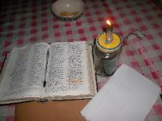
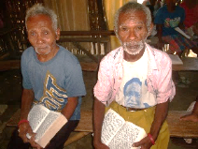
AETA MISSIONS
New Life Baptist Church, Tarik
Porac, Pampanga

Dear Yoke fellows,

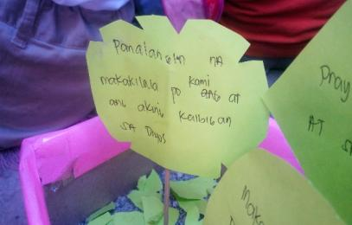
This picture caught my attention and reminds me of what is our Great Commission. This is a project of a child in our Vacation Bible School. This month really becomes a huge blessing to us as baptisms happened in our Church here at Porac with 3 candidates and 4 candidates in our Mission Point in Planas. Truly God gave the increase if we faithfully follow His voice, Praise the Lord! And 2 of those believers decided to study in our Bible School program in the
Church at Tarik, Please Pray for Bro. Eduardo Guttierrez and Sis Jennilyn Dela Cruz. These young people strive to learn more , praying them to be ready on what God has prepared for them someday. Our Bible School is struggling on numbers of students due those members that are illiterate, PLEASE PRAY for it praying partners, because we want to prepare this church to send out missionaries someday, a true native missionaries that can able to reach and speak to other mountain places and preach to those who seek the Truth. Recently we are reaching out to three different places: Tarik,Villa Maria, Planas, and Pasbul, wherein lots of people are regularly listening to God’s word. In the church at Tarik we’re about to reach 50 to 70 people listening to God’s word. Praise God! But what gives me challenge is on how to speak to them in the way they can understand it even more. PLEASE PRAY for more souls to be saved. There are a lot of regular visitors who showed their professions of faith by raising their hands, but we still observing their response towards it. In Church at Tarik we also started little by little to expand and renovate our Church Building. While they are giving to Building Offering, we are able to buy even second-hand good lumber and other materials to build much bigger building, I told them. “ We can’t be faithful in much if we are not faithful in lease!” In our church we do believe that God will bless us if inn those little things that God give if we faithfully give back everything. PLEASE PRAY for God’s provision towards our Church Building, we do not own the land where the building was constructed, it is only borrowed from one of our members in our church. PLEASE PRAY for our missions God has given us in Planas and Pasbul. A lot of people are at thirst listening to the truth. In planas we’re about to have 25 listeners, it is very difficult to preach to these two places in Planas and Pasbul because these places were governed by Catholic Cult. They bought the land, they built houses,school,water system, and many more and told every family that they must join actively to their cult inorder for them to have harmonious yet devilish relationship. PLEASE PRAY for the boldness of these people to stand to the truth and to search the truth, and PLEASE PRAY for His guidance to us, one day somebody told me that in place of Pasbul some people are searching for me to kill me. I still decided to go to that place not concerning of my self but to those native people who regularly listens to His word. PLEASE PRAY also as we help those people who are in need of medicines, recently we are able to helped Nanay Calamunding, an Aeta mother who bears a twin children but they were in pre mature condition. PLEASE PRAY Joshua and Jose as ther grow healthier and pray for their parents Atani and Calamunding to received Christ as their Saviour. We also had medicines for sore eyes taken to the place of Planas and Pasbul, Praise the Lord! At the end of the month of April we also had our VBS (Vacation Bible School) held in our Mother Church in Pandacaqui, New Life Baptist Church.
Then together with the youth in our Church we joined the VBS and really helps the students to know Jesus more in depth, praise the Lord! PLEASE PRAY for the growth in our ministry here in mountain places in Porac. One also in our challenges here is our transportation like motorcycle, recently, the one that I’m using becomes unable to reach those places we have to go due to its unnecessary condition, PLEASE PRAY that we can still able to reach more places to reach the lost. PLEASE PRAY for our upcoming Vacation Bible School in Tarik together with some people in Planas.
Finally Brethren, we want to express our gratitude towards you all as you faithfully pray for us all here in the field, we have some pictures next to this page so that you can see visually our ministry here. As we close this letter, this Bible verse summarized what we have learned all this month.
“And ye shall know the truth, and the truth shall make you free- John 8:32” Then we asked ourselves, who will declare the truth? so that a man makes free.. Please pray for missions and more missionaries.

Your brother in Christ
Bro. Rex Daryll D. Lalu

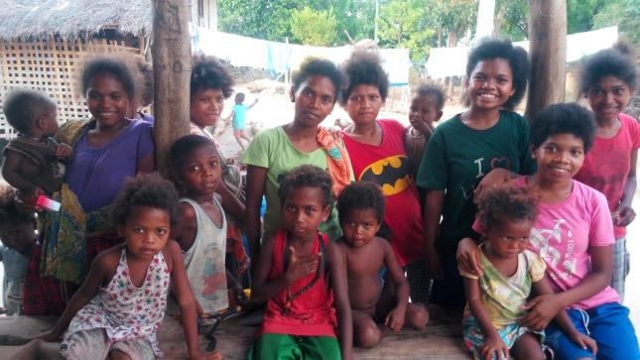
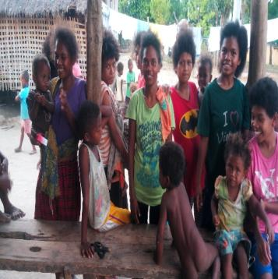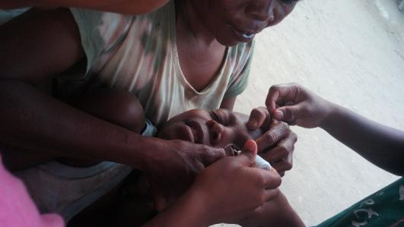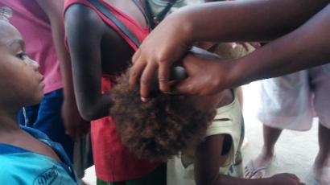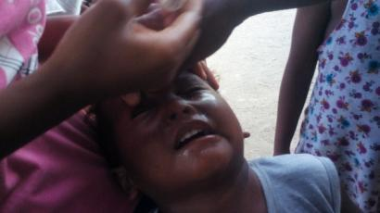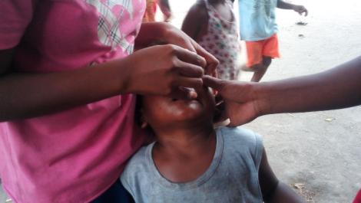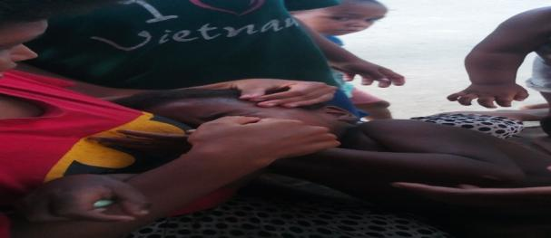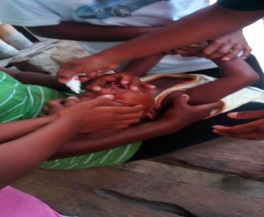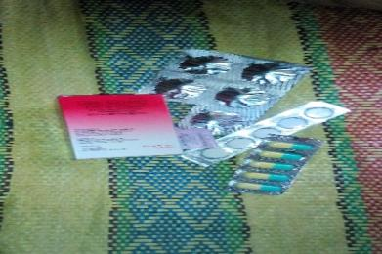
Ministry at Planas
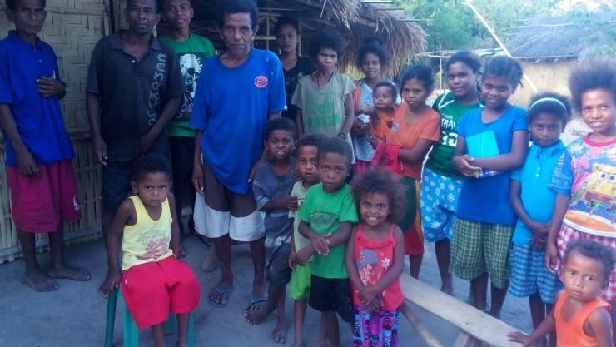
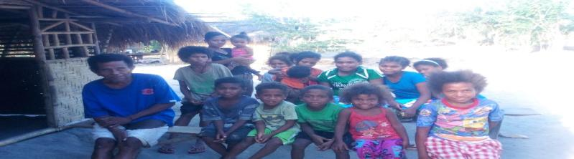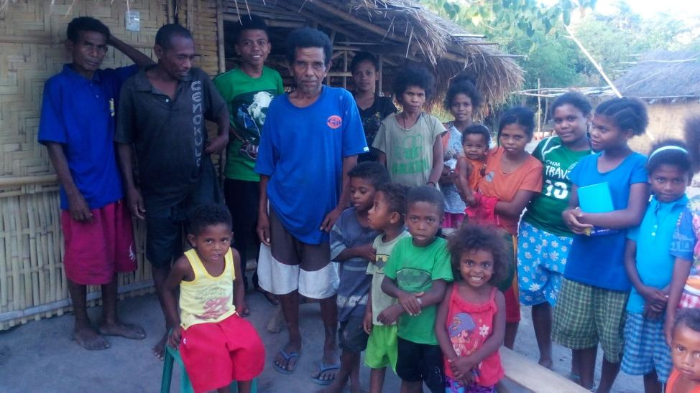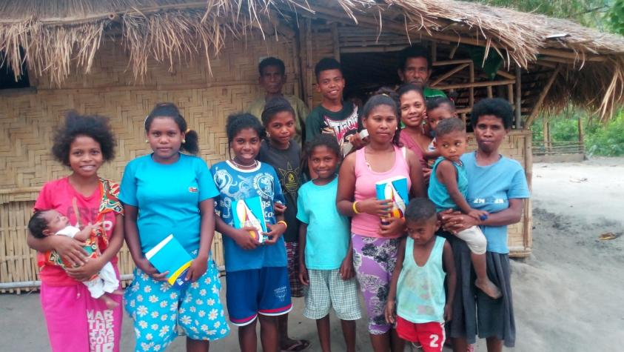
Ministry in Pasbul

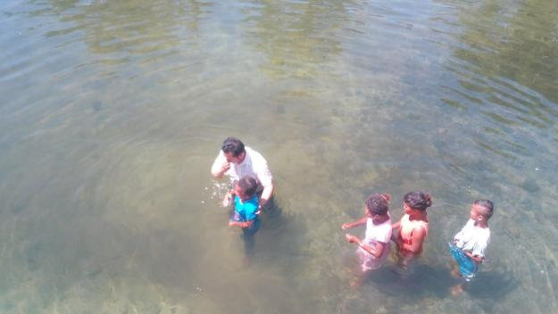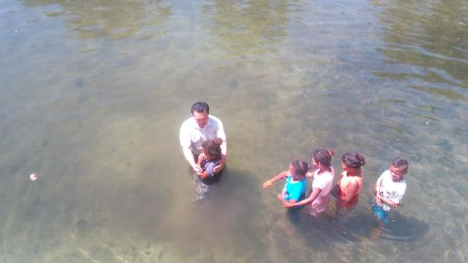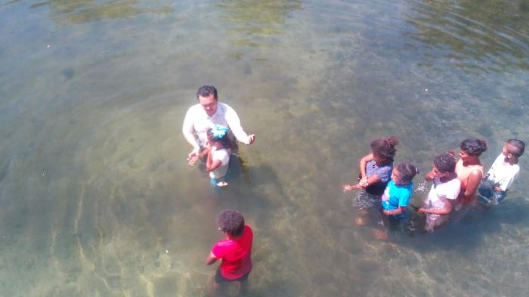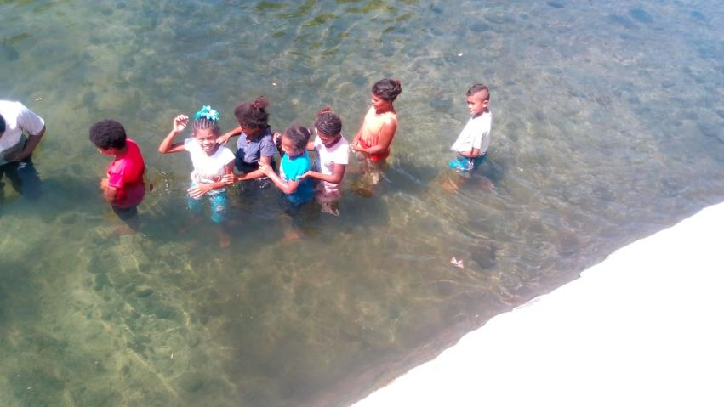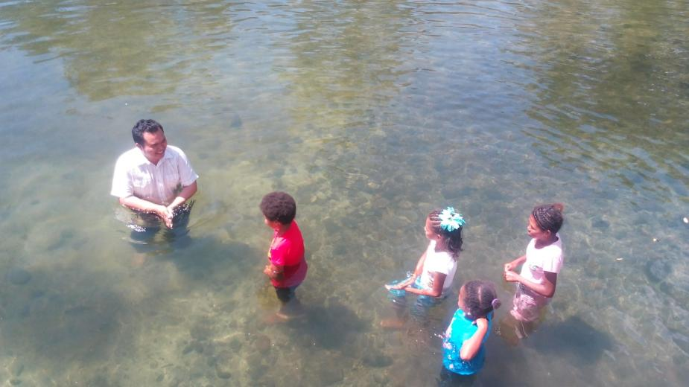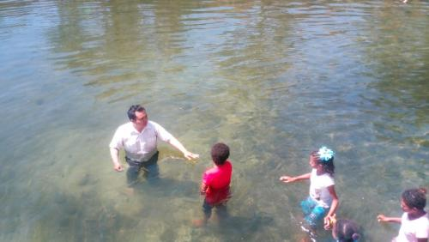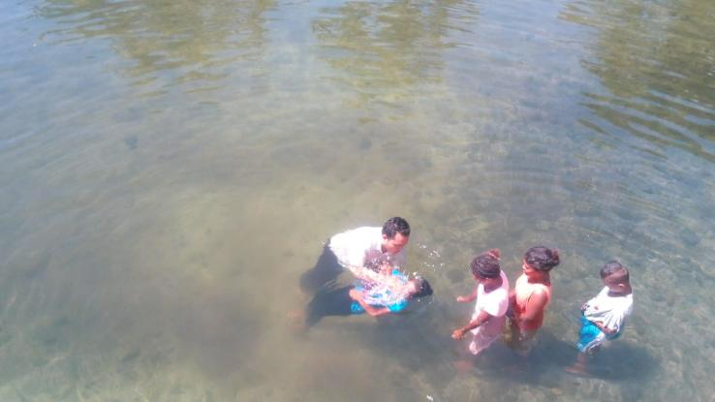

Baptisms

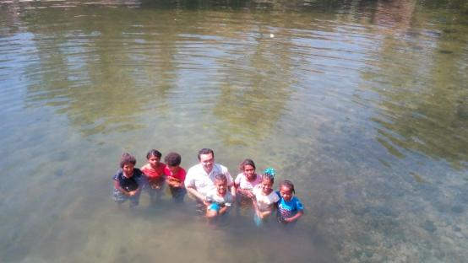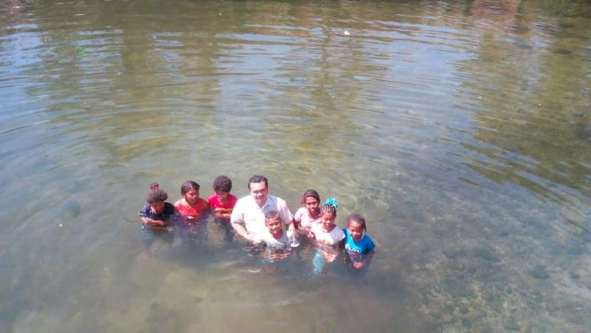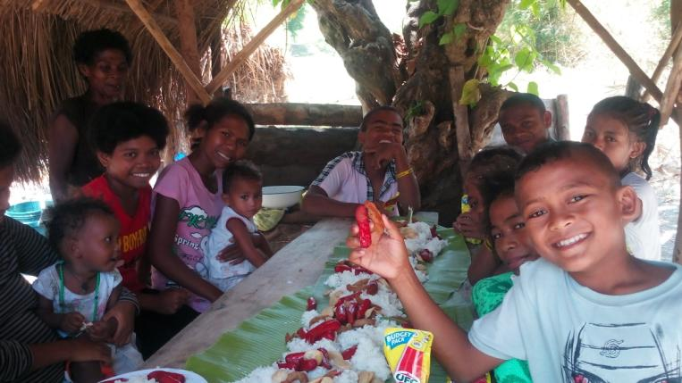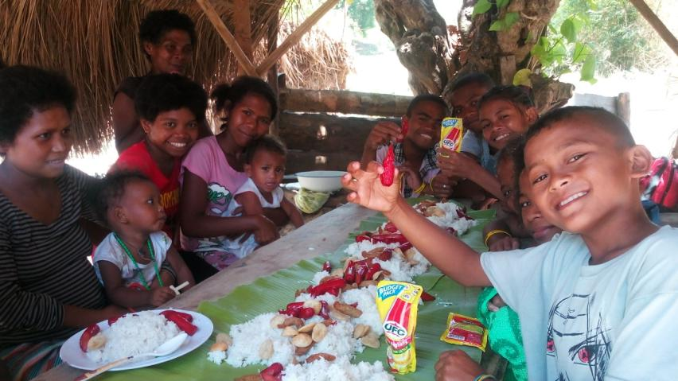
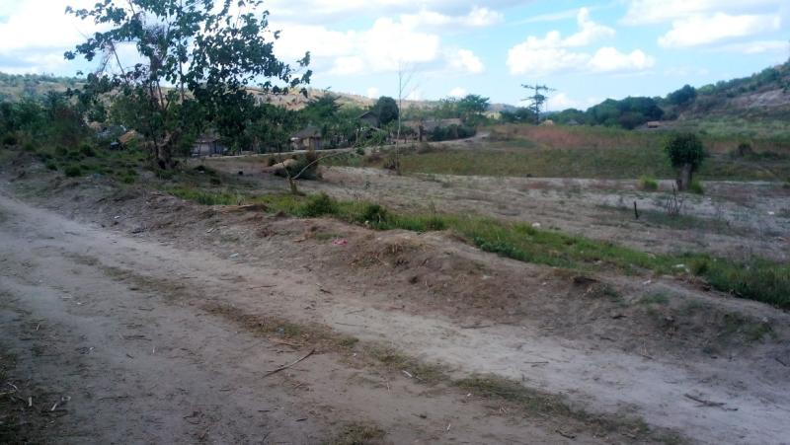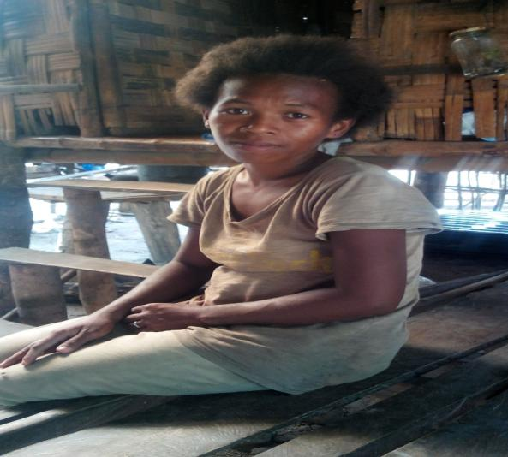
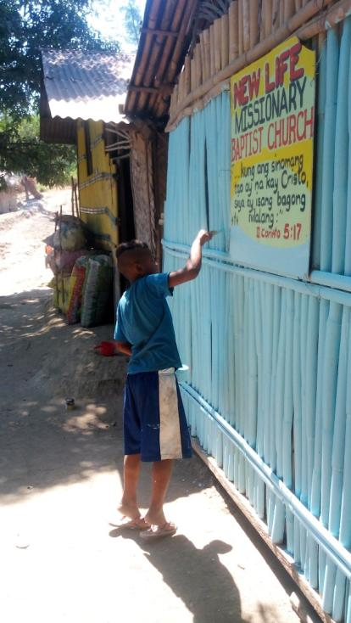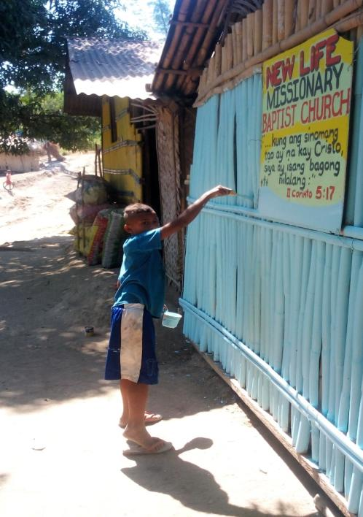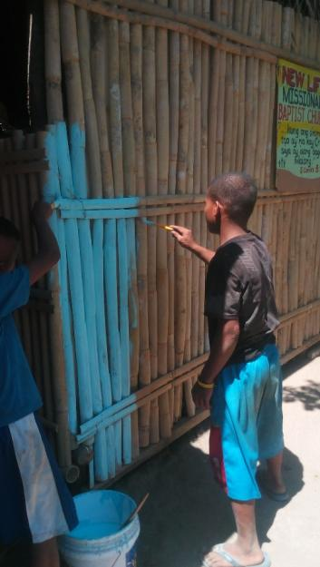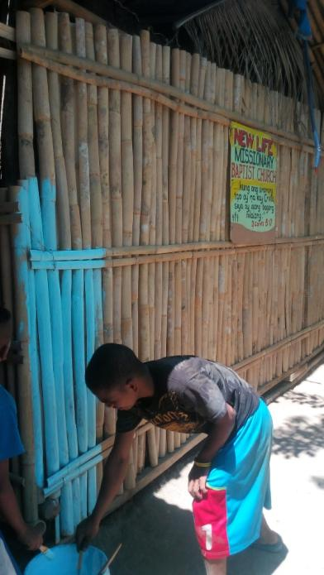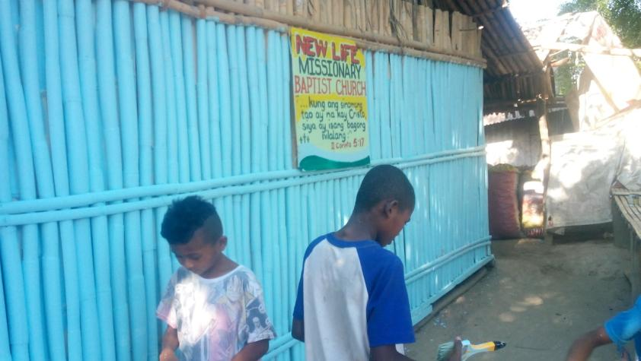
Building Project
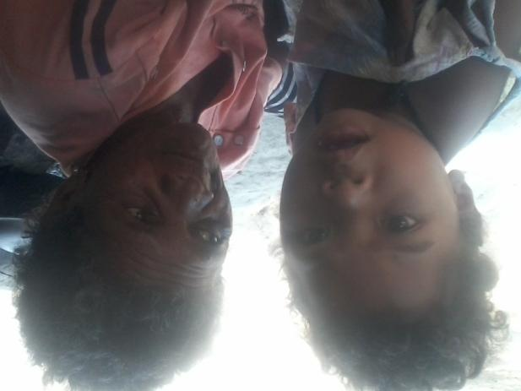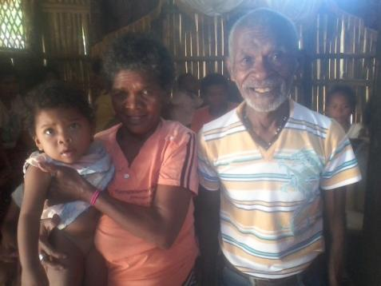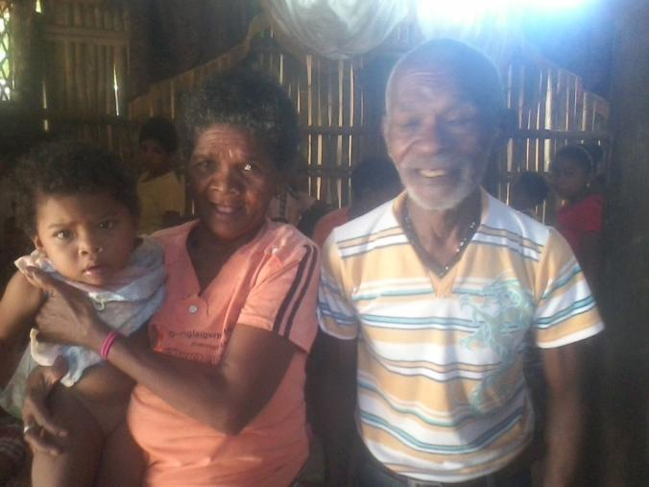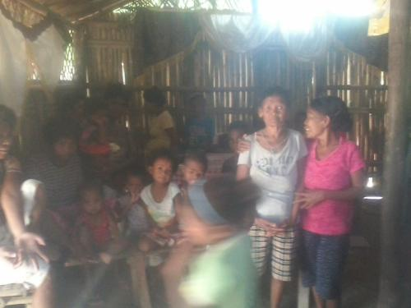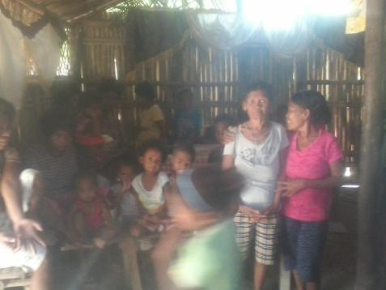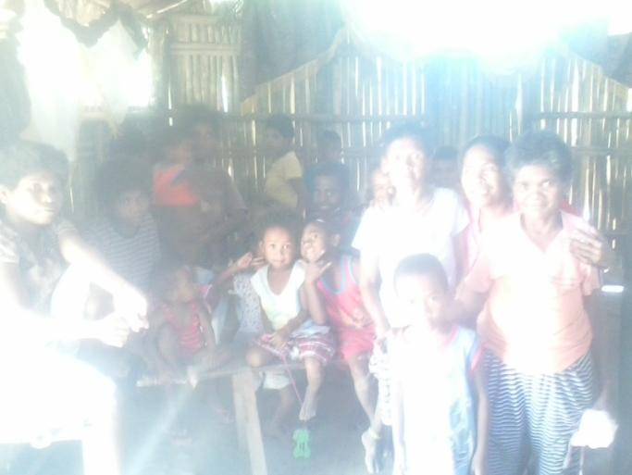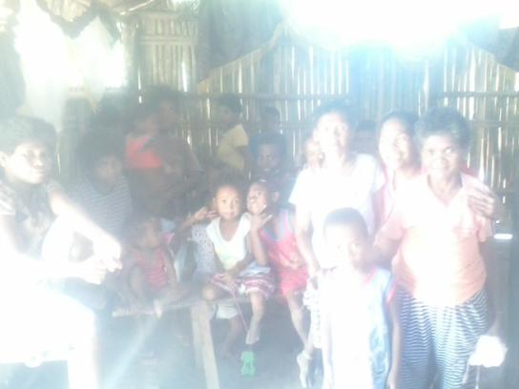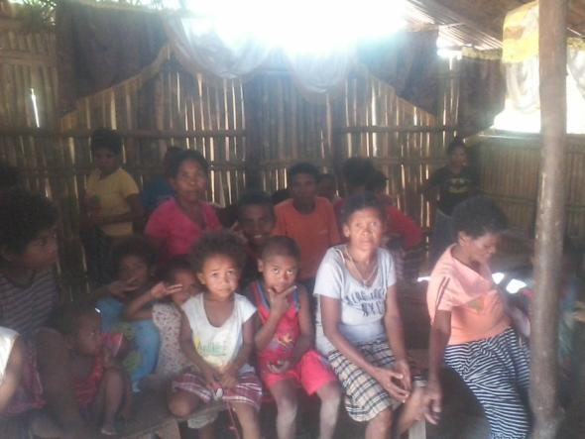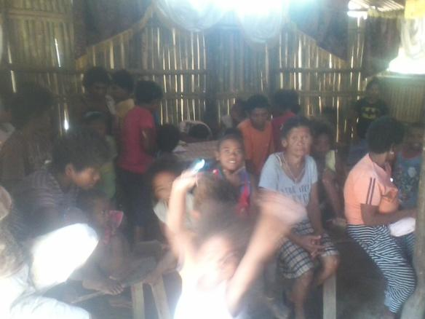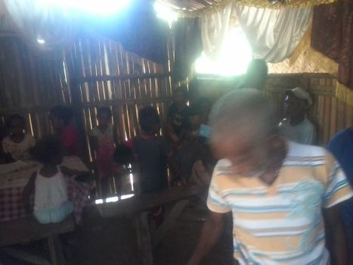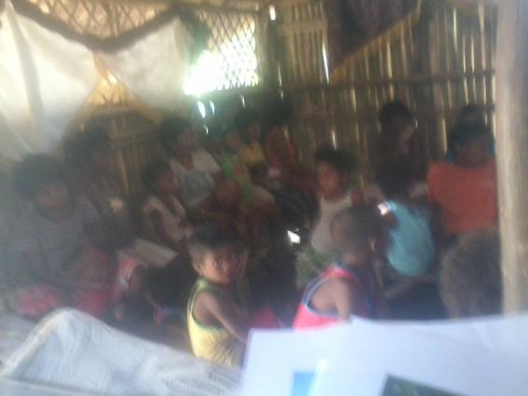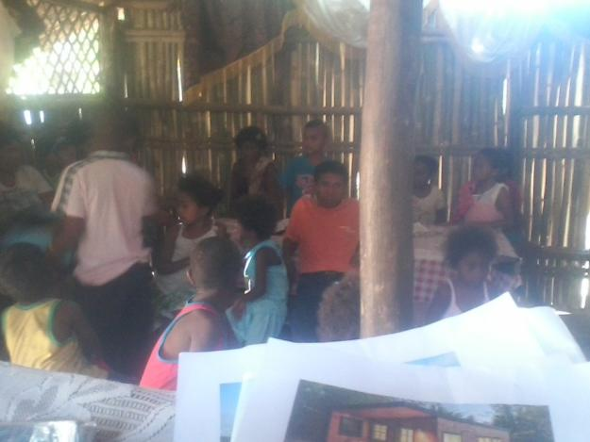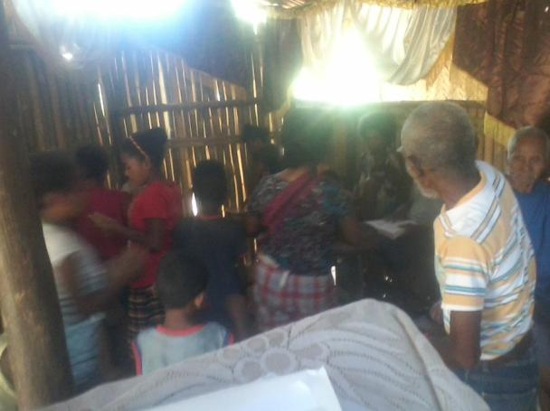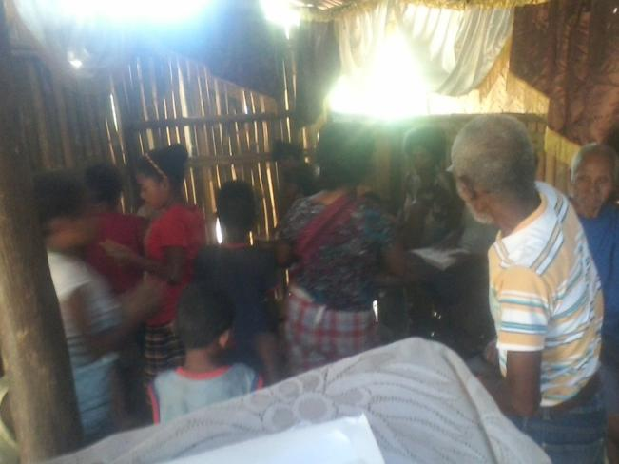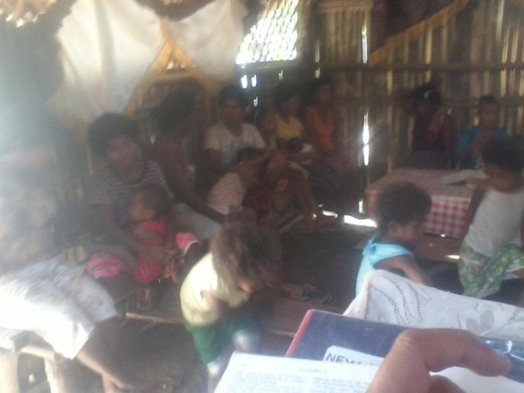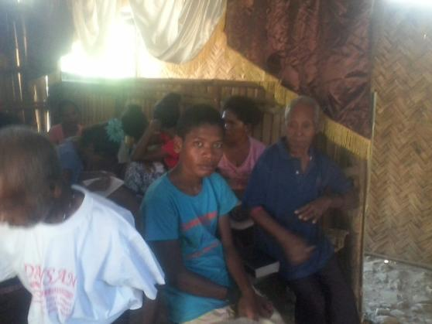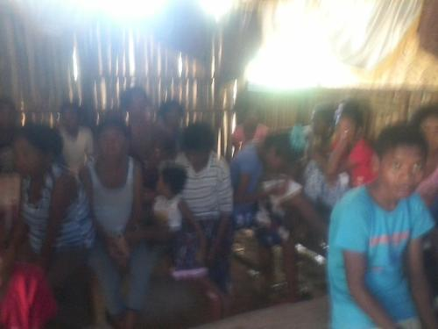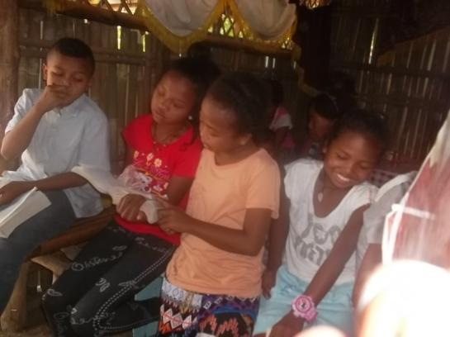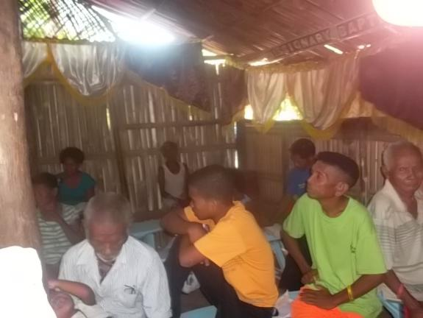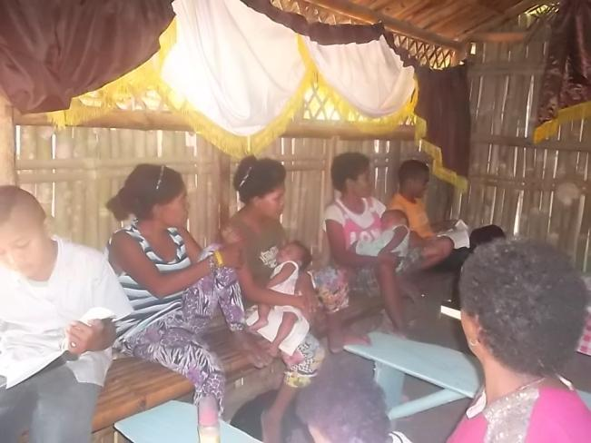
Church Service in Tarik

