Missionary Pastor Rex Daryl Lalu, Sent From New Life Baptist Church, Mexico, Pampanga May, 2016
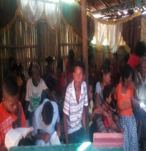
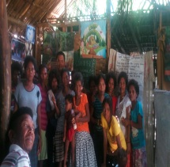
AETA MISSIONS
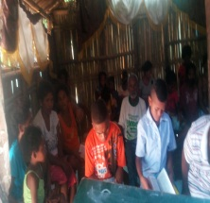
New Life Baptist Church,
Tarik, Porac ,Pampanga

Dear Praying Partners,
We thanked the Lord for your unceasing prayers toward our ministry here in the mountains at Porac, Pampanga. This month has been a huge blessing for us because of God’s grace towards the church and our two mission points(Planas and Pasbul). We already had our Vacation Bible School where in almost 80 people attended for three days, a little bit disappointed from expecting for about 200 listed attender, but I do realized that God still blesses us in that number because supposed to be there were no people in our place because VBS was happened the day after their annual barangay fiesta, and they were obligated to work to pay debts on what they ate on the feast, and most of all, there were 7 mothers who became a students at VBS who continually go to church services regularly . Praise God ! PLEASE PRAY for these 7 mothers (Martia, Arlyn, Aileen, Calamunding, Gina, Alma, Nena) to continue in the right direction where God wants them to go.
3 of them professed to be baptized, and we still observing for their seriousness.
We also had an Eye Medical Missions led by three brethren from another country. It’s been a terrific and heart-melting ministry has occurred, because it causes many opportunity to open people’s eyes to Christ! Even non-aeta people are now regularly listening to the word of God. PLEASE PRAY for salvation of (Loleta,Rio,Coling, Ramon and his family,Bernie,Matangis and his family) I have some pictures at the back so you may see them. We also had the opportunity to reach souls through the Eyes for Christ Ministry in our two mission points. And also had a lot of listeners in His Word.Praise His Name. PLEASE PRAY for the people in Pasbul and Planas. Last few weeks in our Sunday service at Planas, there were 3 men attended the service. After the service they asked me if I can go to their place and preach also to their place, this really breaks my heart and made me realized how few are the labourers of the Lord. They live in Purok 1 , Sitio Binalaba, Mawakat Pampanga, much far in our place for about 3 to 4 hours in distant time . I told them that we will go. PLEASE PRAY for Jomar Liwanag, Narding David, Roberto Ponio for their salvation and for us to be able to reach that new upcoming Mission Place. I do believe that in us, many things is impossible, but when we let God use our lives, impossibility will gone..
PLEASE PRAY for the continuation of our Bible School Class with the topic ,”Doctrine of God”. Please pray for the wisdom of the upcoming students due to English notes that we had. PLEASE PRAY also for our desire and plan to reached students in two Public Schools on Aeta Communities. PLEASE PRAY for our Building Project where in it became a huge challenge for us. The building that we are using recently is good for congregational meentings, but sadly, the owner of it was disfellowed in the church due to their public sins like saying lies and bad murmurings towards the church and Pastor, it became a very unnecessary time for me to feel this way but we believe that God is faithful. It is the first time that we experienced such thing, but we believe that we must keep The House of the LORD clean and Undefiled. PLEASE PRAY for salvation of Agnes Lansang and Jojo Lansang, ALSO PLEASE PRAY for Bro. Miracle Lansang ,one of the Bible School member, because he was the son of recently disfellowed couple. Bro. Miracle cried to me in sadness due to what his parents did. I told him that he must stand and do what was right and to follow the Lord no matter what. Sunday after they have disfellowed, a new couple decided to be baptized,, and we Praise God! For His faithfulness. Please pray for the growth in number and in faith of the church here. We also started our Children Sunday School teaching by Bro. Miracle, thanked God! That this young man can now be trained for greater works for Christ.
A lot of challenges, but greater blessings,please pray for more ministry to be done for the Lord and for more souls to be saved. From the bottom of our hearts, we thanked each and everyone of you for your time to read our report and prayers toward this ministry. We believe that, “We have a great need for Christ,and we have a great Christ for our need.-Charles Spurgeon”

ADDITIONAL PRAYERS

- Please pray for our meetintg places in our mission points to be established more firmly (Tarik,Planas,Pasbul)
- -Salvation of people in the field
- -more labourers for the work of the Lord
- -Our transportation vehicle to help us reach far places and to consume and to redeem time .(Not a luxury car or what, not for ourselves but for the ministry of the Lord, even a Carabao that can reached peak of the mountain will do.)
- Upcoming baptism service this June.
- To open the opportunity to teach Public Schools

Your fellow-labourers in Christ,
Bro. Rex Daryll D. Lalu

Our Sunday School room for Children.

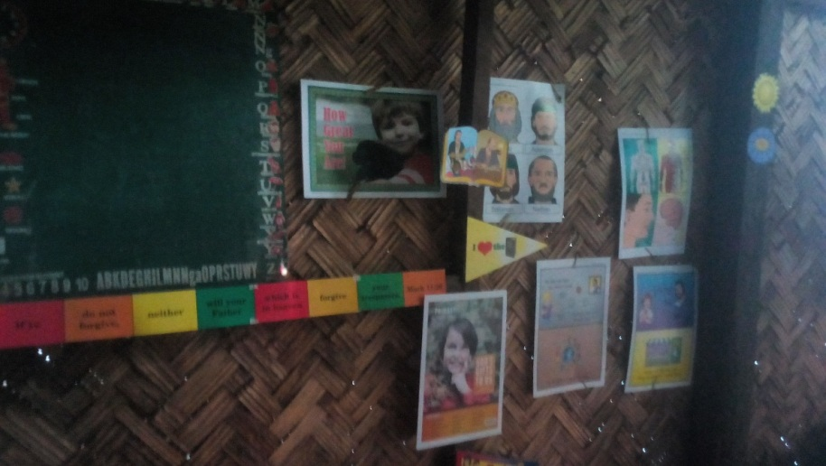

Our Mothers in the Church

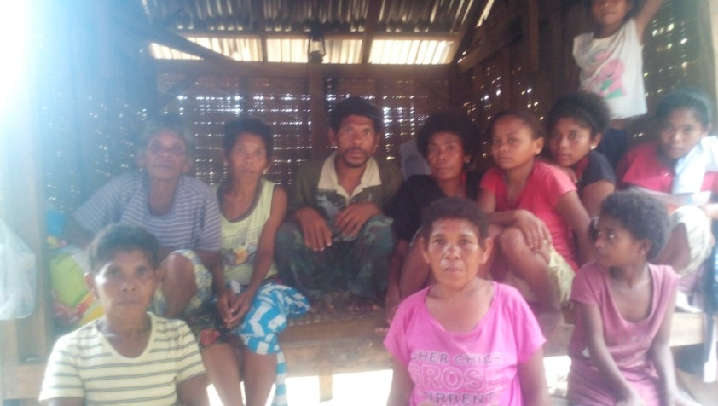
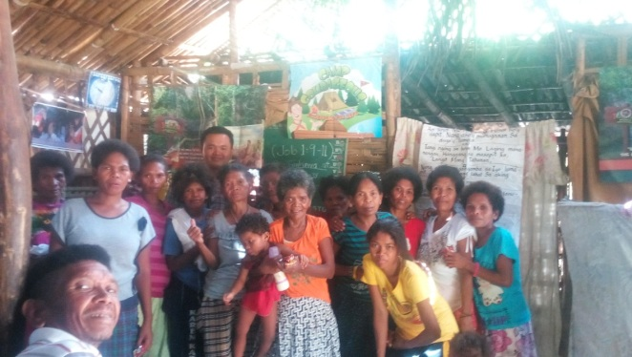

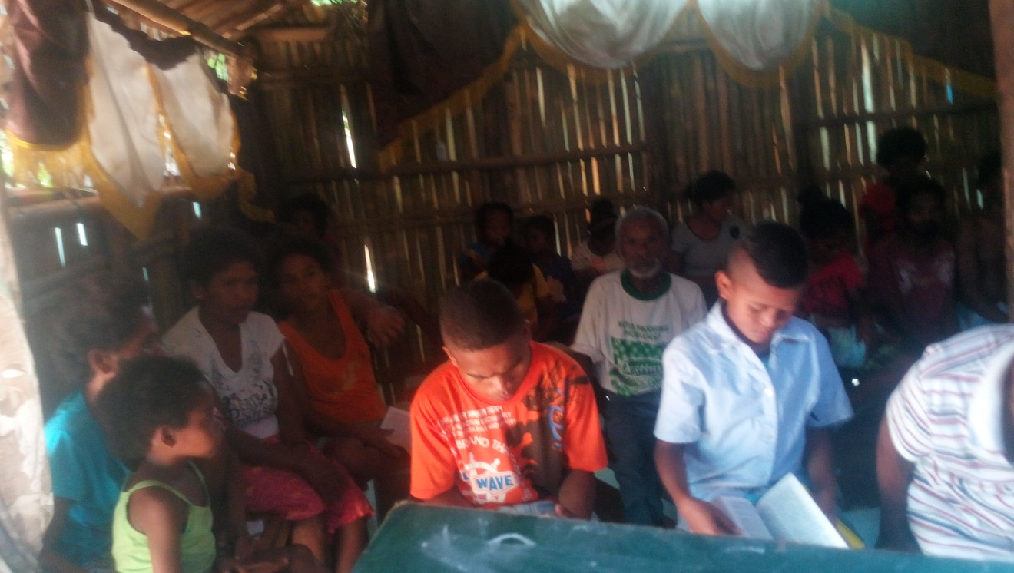
Sunday Afternoon Service

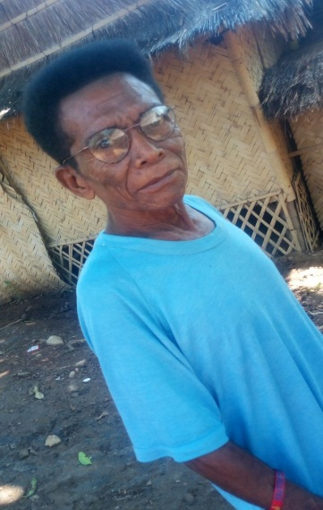
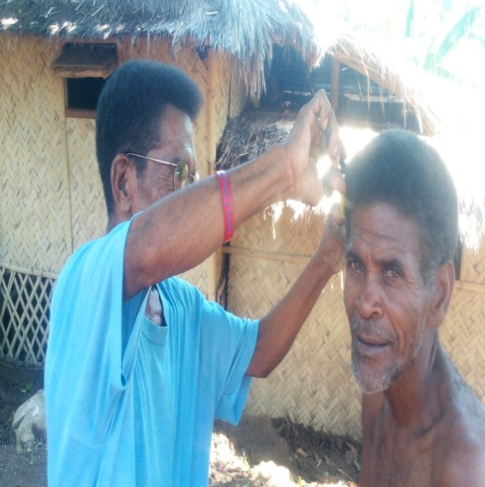

Back to work cutting hair after the Eyes for Christ ministry. (Larry)

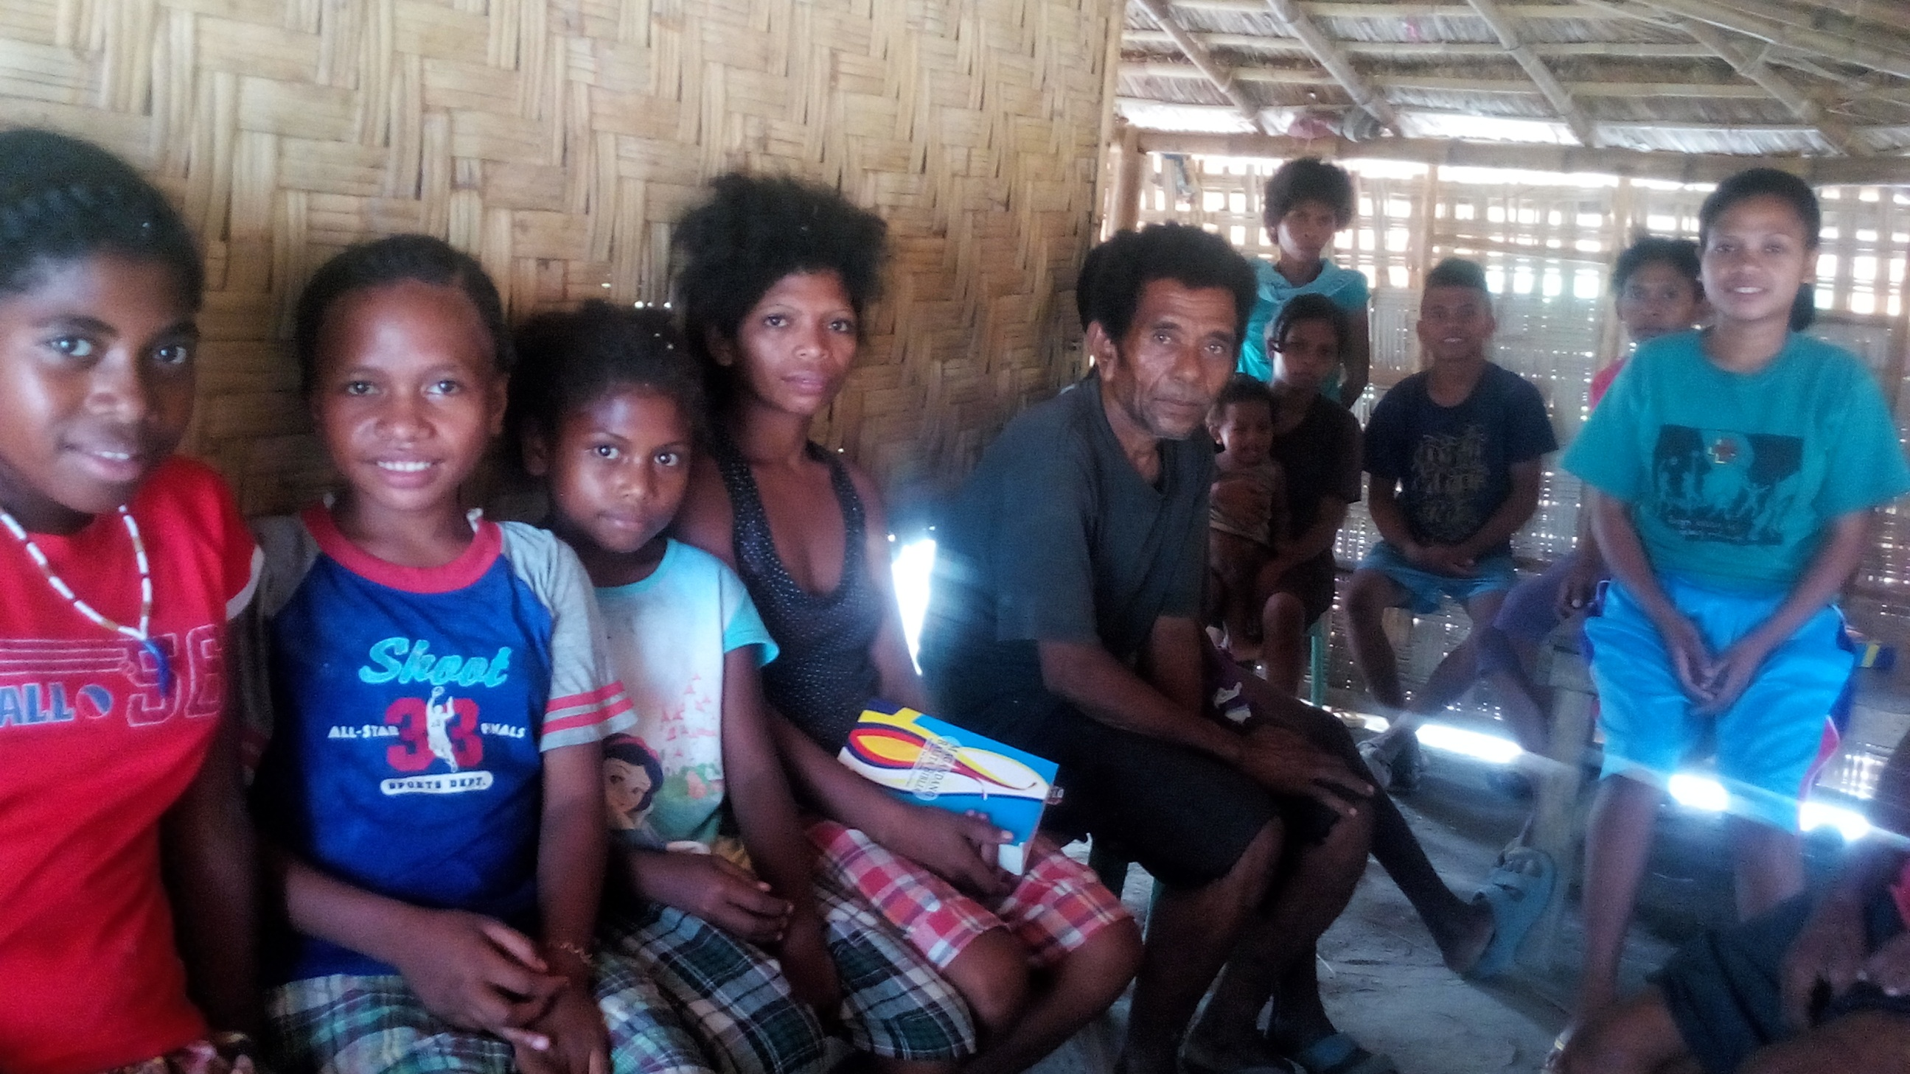
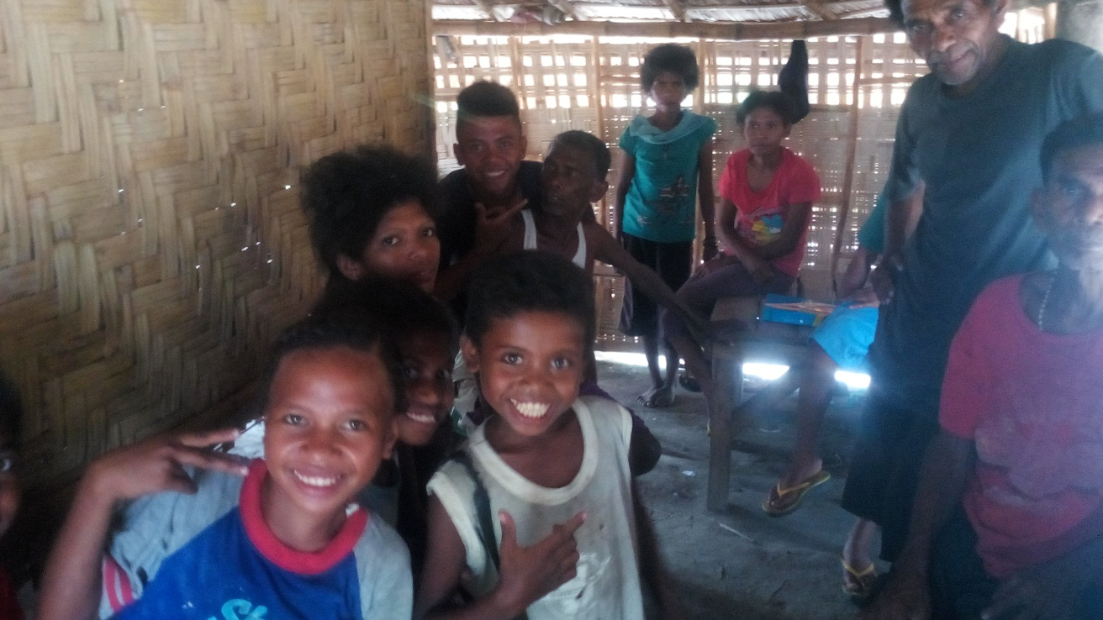
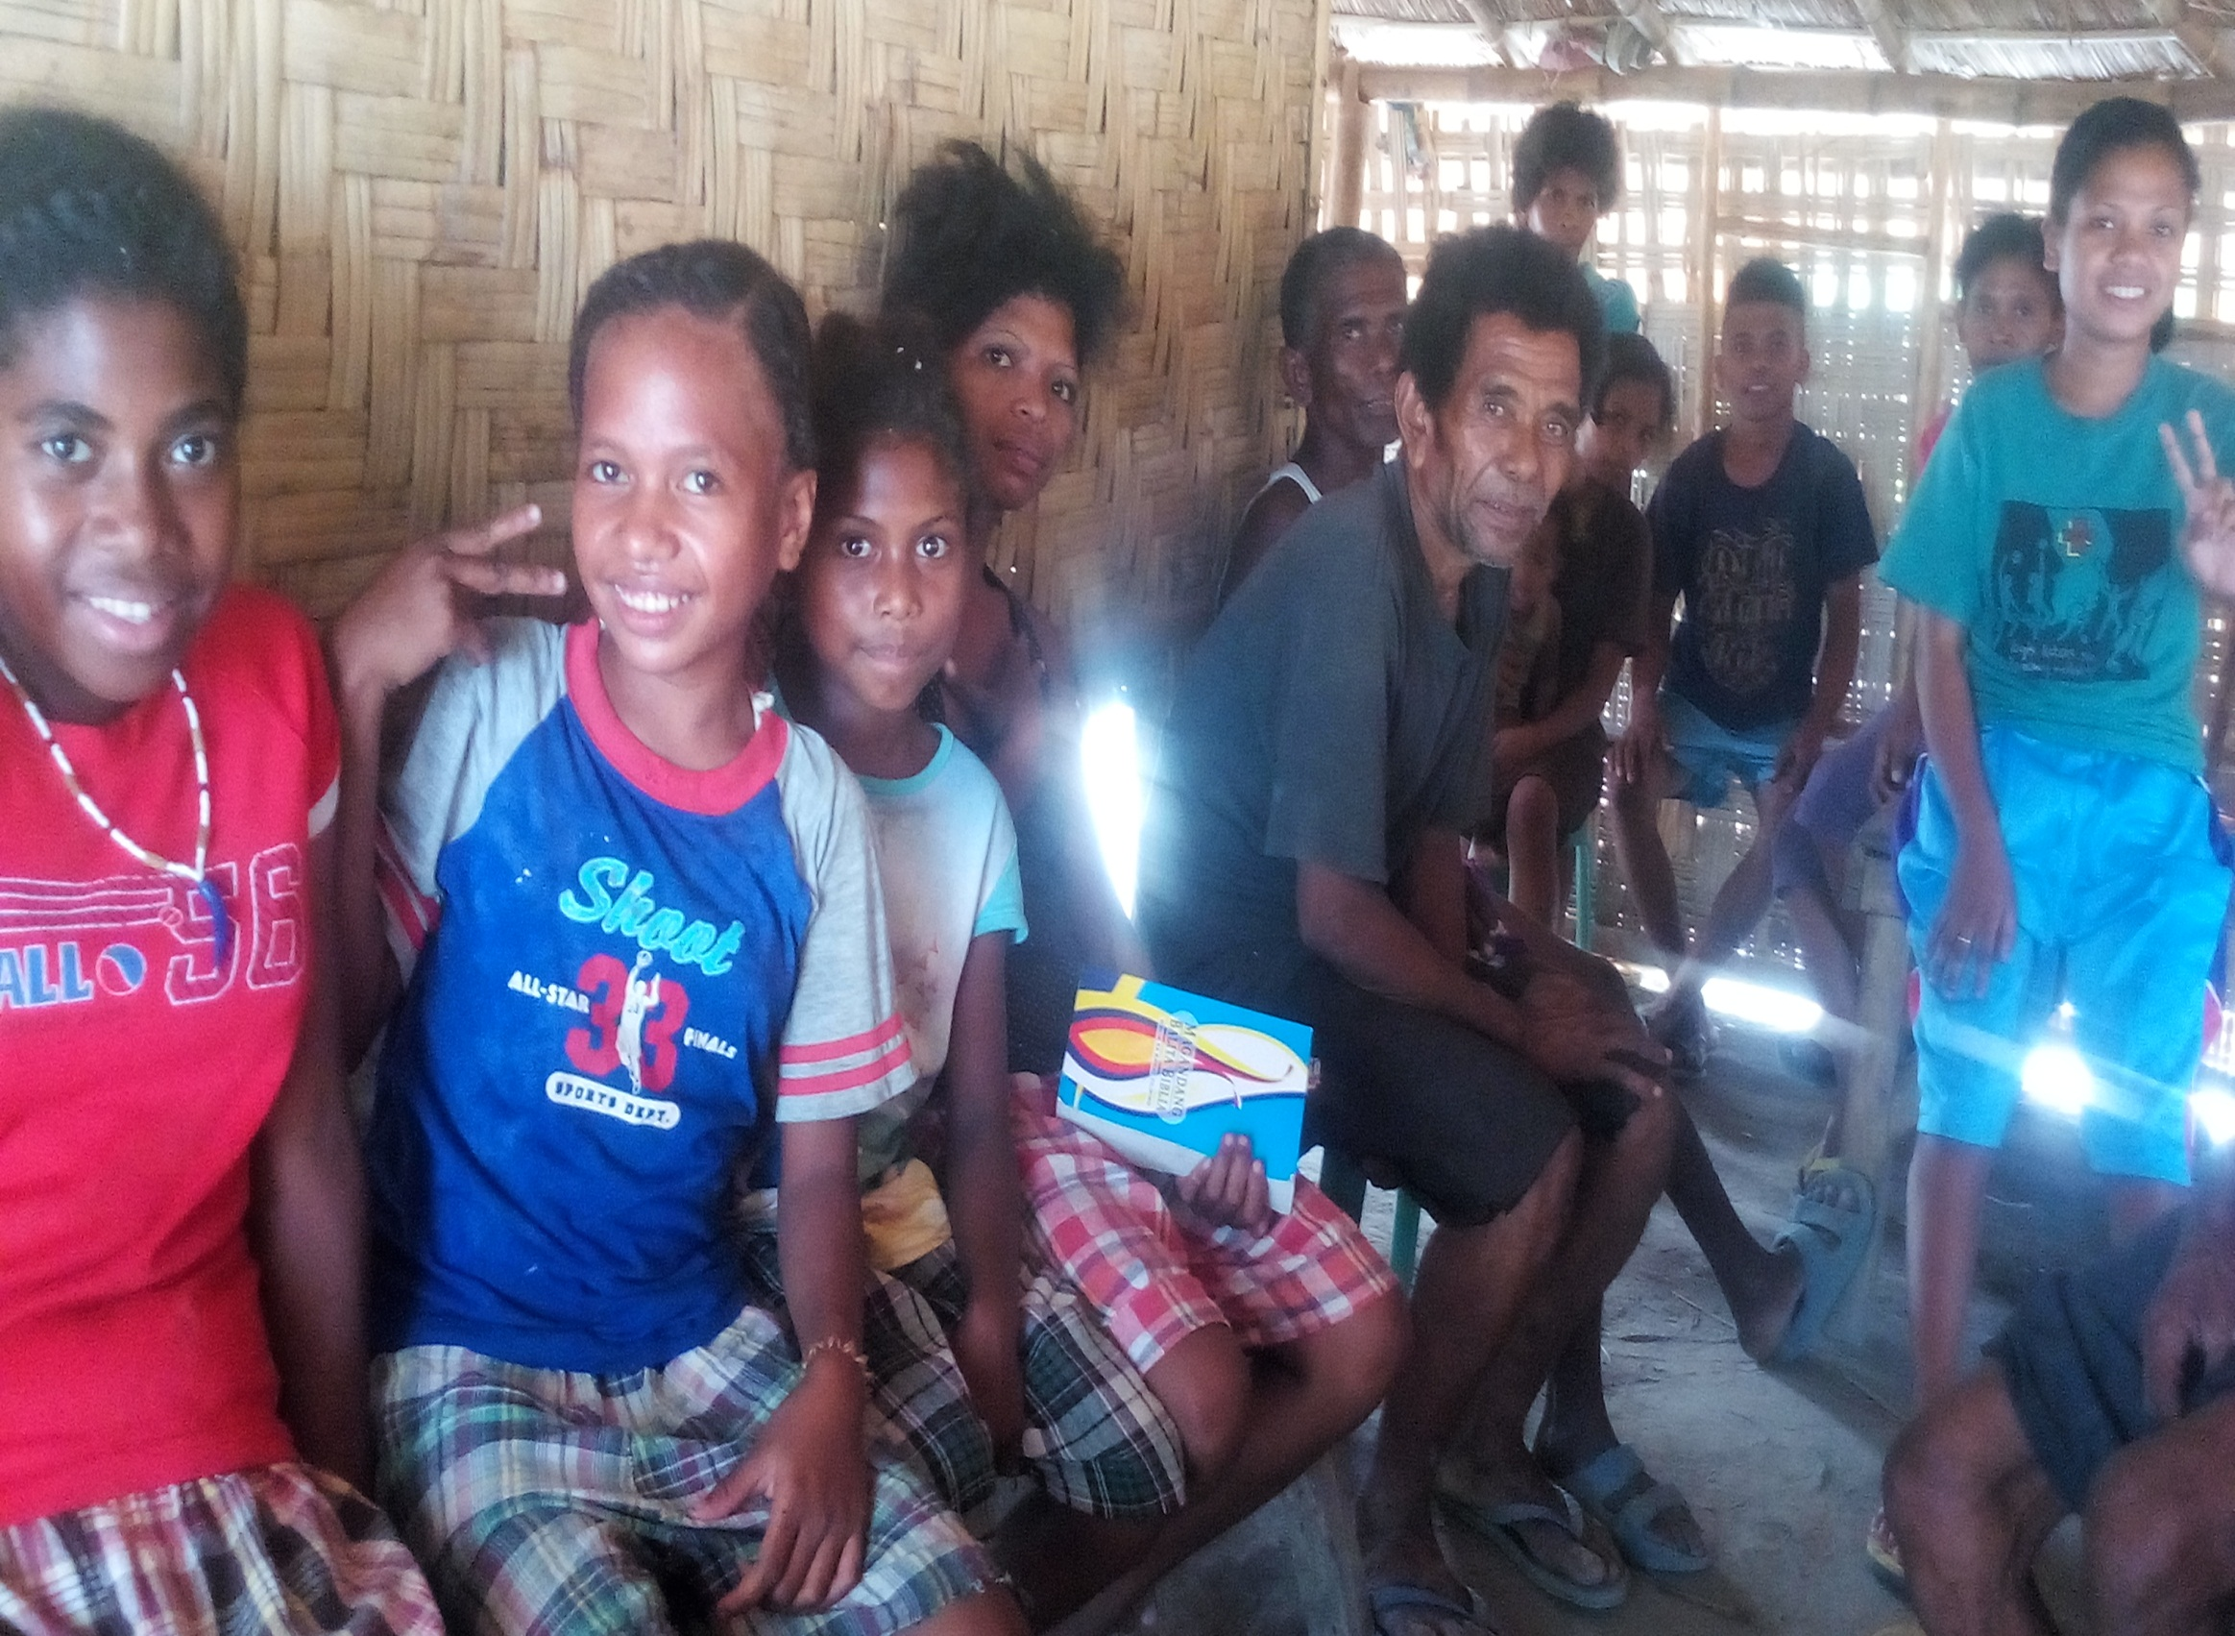
People at Pasbul
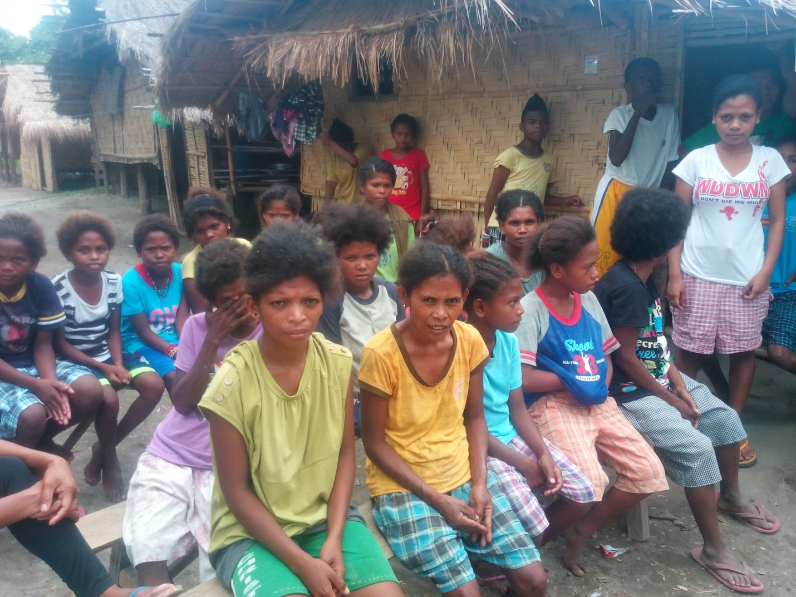

New and regular listeners at Planas.
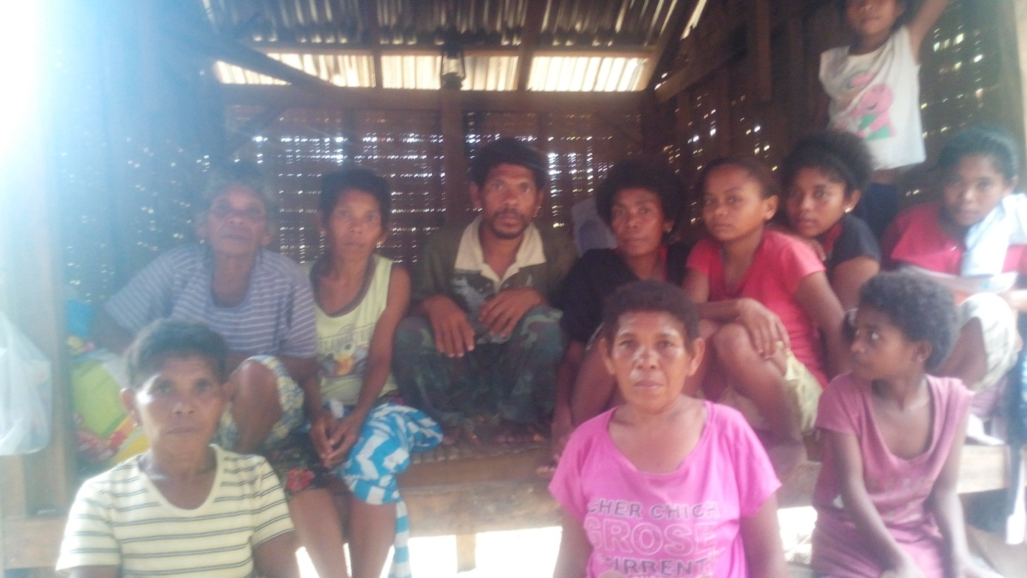
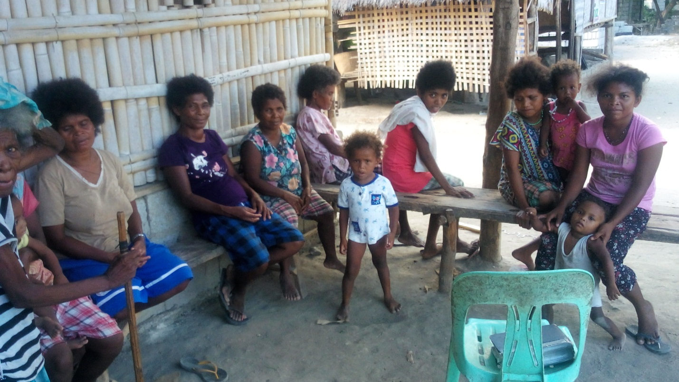

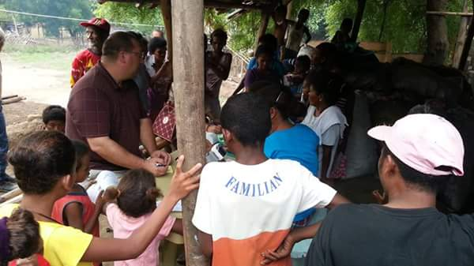
Eyes on Christ Ministry.

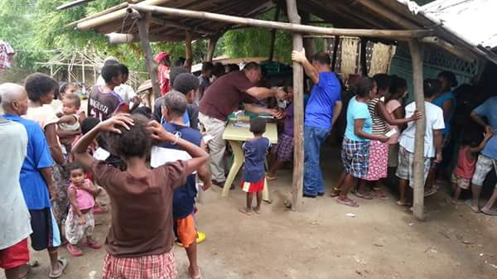

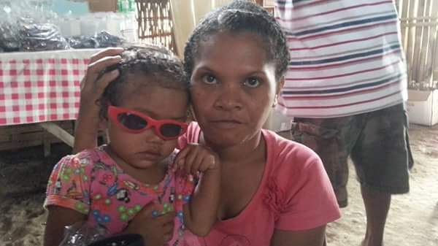

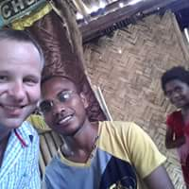

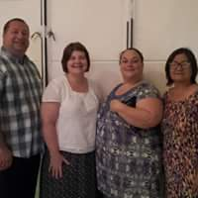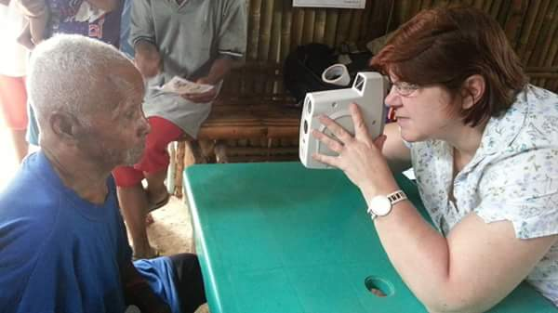
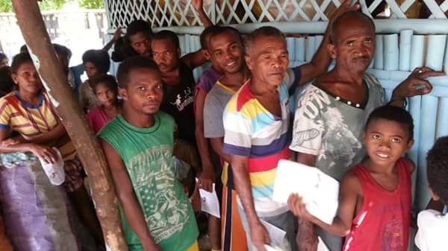
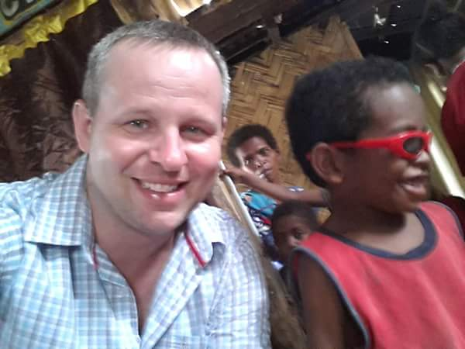

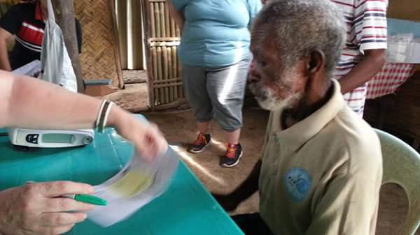

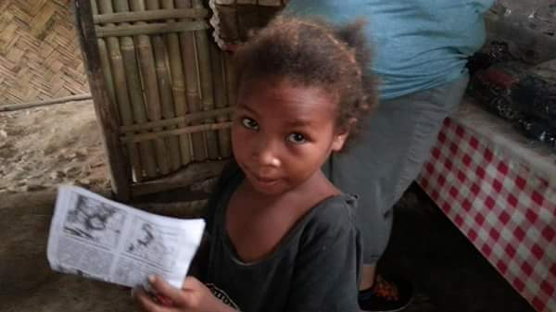

THANK YOU!

